# **Spring Microservices Application**

We are going to create a Spring Microservices which is based on Spring Boot. It uses Spring Cloud and kubernetes dependencies as well. There are following microservices we are going to develop:

1. **Config-server**
2. **eureka-server:** This application is developed to register all the microservices. So that every microservice can communicate with each other without knowing their IP address of the microservice.
3. **gateway-service:** A gateway is a single-entry point into the system, used to handle requests by routing them to the corresponding microservice.
4. **common-service:**
5. **auth-service**
6. **project-service:**
7. **people- service:**
8. **account-service:**
9. **data-upload-service**
10. **gateway-service:**
11. **cache-service**
12. **message-sender-service**
13. **Kafka-producer-service**
14. **Kafka-consumer-service**
15. **common-service**
16. **k8s: It contains the common files used in Kubernetes.**

**Following implementation in details:**

* **Cache using Hazelcast (Embedded Distributed Cache)**
* **Sleuth and Zipkin**
* **Istio (Service Mesh: Sidecar Container: Grafana, Kaili and Distributed tracing using Jager)**
* **ELK(Stack)**
* **Helm**
* **Microservices in Dev Environment**

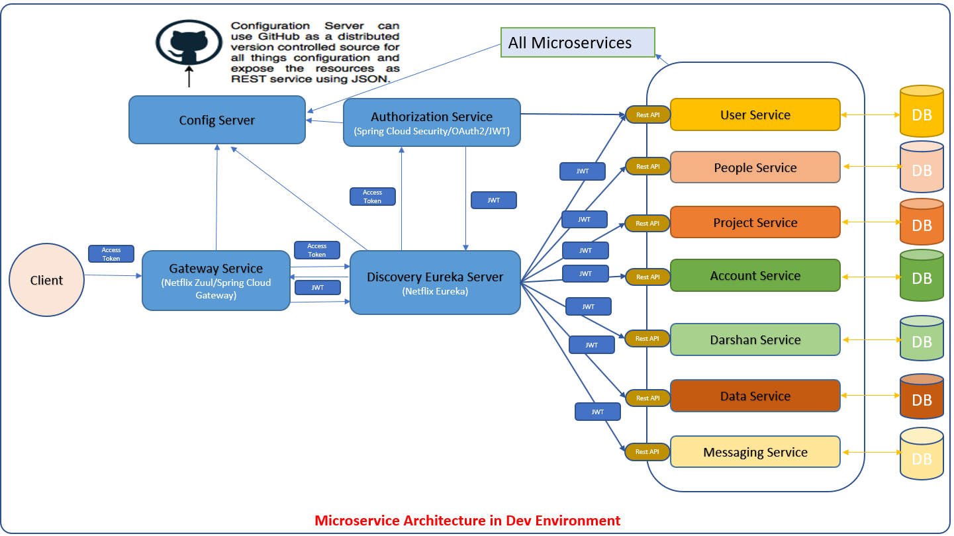

* 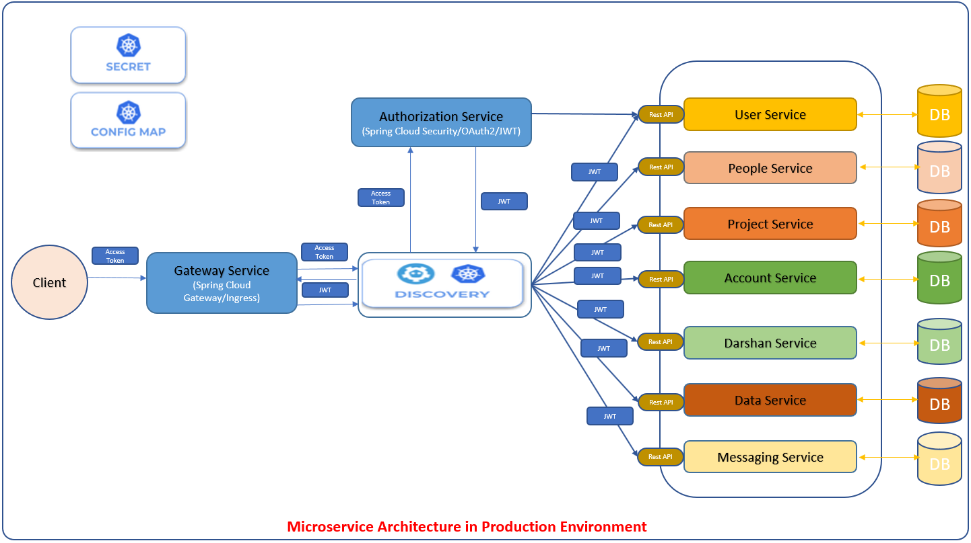**Microservices in Production Environment (Kubernetes)**
* **Multi Module Project**

We are going to create a Spring Microservices multi module project as shown in the diagram below

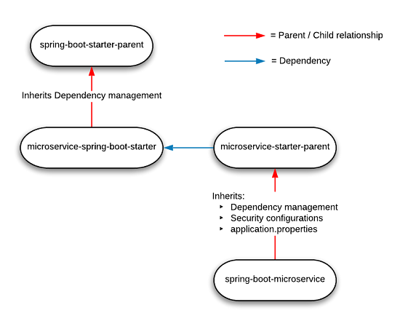

**Parent pom.xml**

Parent pom.xml will be inherited by other microservices.

<project xmlns=*"http://maven.apache.org/POM/4.0.0"* xmlns:xsi=*"http://www.w3.org/2001/XMLSchema-instance"*

xsi:schemaLocation=*"http://maven.apache.org/POM/4.0.0 http://maven.apache.org/xsd/maven-4.0.0.xsd"*>

<modelVersion>4.0.0</modelVersion>

<groupId>com.jmk</groupId>

<artifactId>bjjd-microservices</artifactId>

<version>0.0.1-RELEASE</version>

<packaging>pom</packaging>

<parent>

<groupId>org.springframework.boot</groupId>

<artifactId>spring-boot-starter-parent</artifactId>

<version>2.2.4.RELEASE</version>

<relativePath /> <!-- lookup parent from repository -->

</parent>

<properties>

<java.version>11</java.version>

<maven.compiler.source>${java.version}</maven.compiler.source>

<maven.compiler.target>${java.version}</maven.compiler.target>

<springfox-version>2.7.0</springfox-version>

<hibernate.version>5.4.10.Final</hibernate.version>

<spring-cloud.version>Hoxton.SR4</spring-cloud.version>

<maven-jar-plugin.version>3.1.1</maven-jar-plugin.version>

<jmk-version>0.0.1-RELEASE</jmk-version>

</properties>

<dependencies>

<!-- Spring Boot Starter Dependencies -->

<dependency>

<groupId>org.springframework.boot</groupId>

<artifactId>spring-boot-starter-web</artifactId>

</dependency>

<dependency>

<groupId>org.springframework.boot</groupId>

<artifactId>spring-boot-starter-tomcat</artifactId>

</dependency>

<!-- Actuator is mainly used to expose operational information about the

running application — health, metrics, info, dump, env, etc. -->

<dependency>

<groupId>org.springframework.boot</groupId>

<artifactId>spring-boot-starter-actuator</artifactId>

</dependency>

<!-- Spring Cloud Starter Dependencies -->

<!-- Spring Cloud Starter Config is required to connect config server -->

<dependency>

<groupId>org.springframework.cloud</groupId>

<artifactId>spring-cloud-starter-config</artifactId>

</dependency>

<!-- Spring Cloud Starter Kubernetes is required for Kubernetes -->

<dependency>

<groupId>org.springframework.cloud</groupId>

<artifactId>spring-cloud-starter-kubernetes-all</artifactId>

<!-- <version>1.1.2.RELEASE</version> -->

</dependency>

<!-- Distributed Logging Api -->

<dependency>

<groupId>org.springframework.cloud</groupId>

<artifactId>spring-cloud-starter-sleuth</artifactId>

</dependency>

<!-- Spring Hystrix : Circuit Breaker-->

<dependency>

<groupId>org.springframework.cloud</groupId>

<artifactId>spring-cloud-starter-netflix-hystrix</artifactId>

</dependency>

<!-- Spring Open Feign Client -->

<dependency>

<groupId>org.springframework.cloud</groupId>

<artifactId>spring-cloud-starter-openfeign</artifactId>

</dependency>

<!-- Spring Cloud Netflix Eureka Client -->

<dependency>

<groupId>org.springframework.cloud</groupId>

<artifactId>spring-cloud-starter-netflix-eureka-client</artifactId>

</dependency>

<!-- Spring Netflix ribbon LoadBalancer -->

<dependency>

<groupId>org.springframework.cloud</groupId>

<artifactId>spring-cloud-starter-netflix-ribbon</artifactId>

</dependency>

<!--SpringFox dependencies -->

<dependency>

<groupId>io.springfox</groupId>

<artifactId>springfox-swagger2</artifactId>

<version>${springfox-version}</version>

</dependency>

<dependency>

<groupId>io.springfox</groupId>

<artifactId>springfox-swagger-ui</artifactId>

<version>${springfox-version}</version>

</dependency>

<dependency>

<groupId>com.github.joschi.jackson</groupId>

<artifactId>jackson-datatype-threetenbp</artifactId>

<version>2.6.4</version>

</dependency>

<!-- Lombok data -->

<dependency>

<groupId>org.projectlombok</groupId>

<artifactId>lombok</artifactId>

<scope>provided</scope>

</dependency>

<!-- spring-boot-starter-test “Starter”, which imports both Spring Boot

test modules as well as JUnit, AssertJ, Hamcrest, and a number of other useful

libraries. -->

<dependency>

<groupId>org.springframework.boot</groupId>

<artifactId>spring-boot-starter-test</artifactId>

<scope>test</scope>

</dependency>

</dependencies>

<dependencyManagement>

<dependencies>

<dependency>

<groupId>org.springframework.cloud</groupId>

<artifactId>spring-cloud-dependencies</artifactId>

<version>${spring-cloud.version}</version>

<type>pom</type>

<scope>import</scope>

</dependency>

</dependencies>

</dependencyManagement>

<profiles>

<profile>

<id>dev</id>

<activation>

<activeByDefault>true</activeByDefault>

</activation>

<properties>

<spring.profiles.active>dev</spring.profiles.active>

</properties>

</profile>

<profile>

<id>prod</id>

<properties>

<spring.profiles.active>prod</spring.profiles.active>

</properties>

</profile>

</profiles>

<build>

<sourceDirectory>src/main/java</sourceDirectory>

<plugins>

<plugin>

<groupId>org.springframework.boot</groupId>

<artifactId>spring-boot-maven-plugin</artifactId>

<executions>

<execution>

<goals>

<goal>repackage</goal>

</goals>

</execution>

</executions>

</plugin>

</plugins>

</build>

<modules>

<module>common-service</module>

<module>user-service</module>

<module>project-service</module>

<module>account-service</module>

<module>darshan-service</module>

<module>data-upload-service</module>

<module>eureka-server</module>

<module>message-sender-service</module>

<module>people-service</module>

<module>config-server</module>

<module>auth-service</module>

<module>gateway-service</module>

<!-- Additional Modules -->

<module>kafka-producer-service</module>

<module>kafka-consumer-service</module>

<module>cache-service</module>

</modules>

</project>

## **People-Mgmt-Service**

After that made the following changes:



Follow the document to implement project-mgmt-service: **DemoProjectWork-member-mgmt-service.doc** along with the following changes:

|  |  |
| --- | --- |
| Database/Schema Name | person\_db |
| User name | bjjd |
| Password | bjjd\_379 |

**Commands:**

Connect with the root with the following credentials in MySQL database command line or UI

User Id: root

Password: bjjd

* create database person\_db;
* create user 'bjjd'@'%' identified by 'bjjd\_379';
* grant all on person\_db.\* to 'bjjd'@'%';
* Use the following document related to the swagger, database scripts, ER diagram of Users:



* 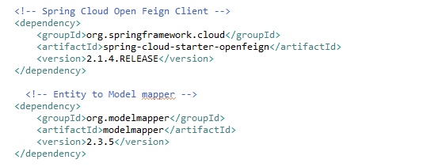Move the following maven dependency from project-mgmt-service to common-service to make it centralize and create the bean in common service for these features so that these can be used in various microservices.

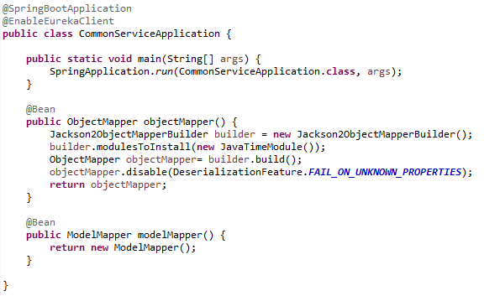

* Add the following dependencies in pom.xml with the following considerations:
  + Spring Cloud Starter Config: This dependency is required to connect to the Config Server
  + Spring Boot Starter Parent: update the version: 2.2.4.RELEASE highlighted in yellow colour.
  + Spring Cloud version: upgraded to Hoston.SR4. It is highlighted in yellow colour.
  + Maven Jar Plugin Version: After the above updates, pom is giving compiler error in pom.xml so downgraded version of maven jar plugin to 3.1.1. It is highlighted in yellow colour.

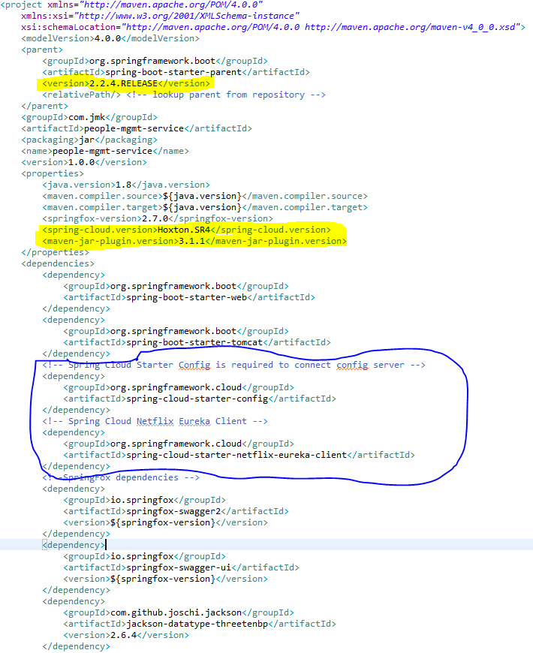

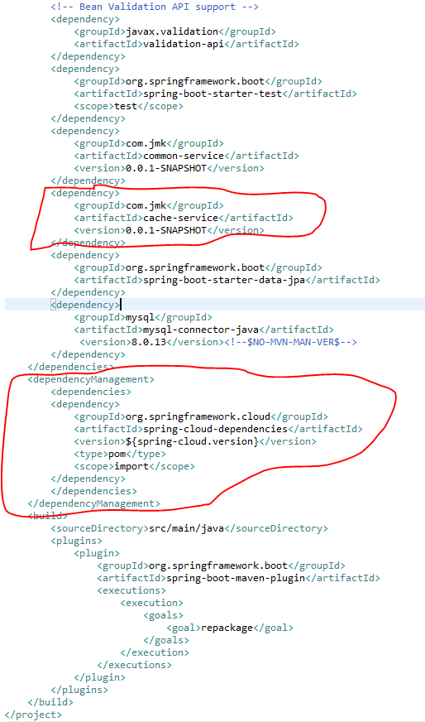

* Rename the package of io.swagger to com.jmk.people
* Rename and refactor the Swagger2SpringBoot.java to PeopleMgmtRestApplication.java with the following details:
  + Enable Eureka Client so that it can be register with Eureka Server
  + Enable JpaRepositories
  + Enable EnableSwagger2 so that we can view the document api

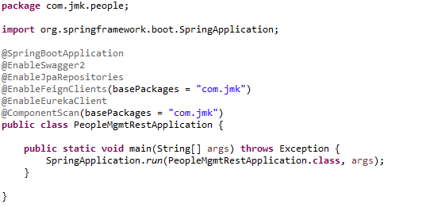

* Moved the following main application.properties along with different profiles to git repository: **bjjd-config-server-git-repo**



* In this application, still there will be an application.properties file but it will have the following minimum details:
  + Name of the application
  + Active Default Profile
  + Cloud Config server URI with port



* People Mgmt Service APIS
  + DevoteeApi and DevoteeApiController

DevoteeApi

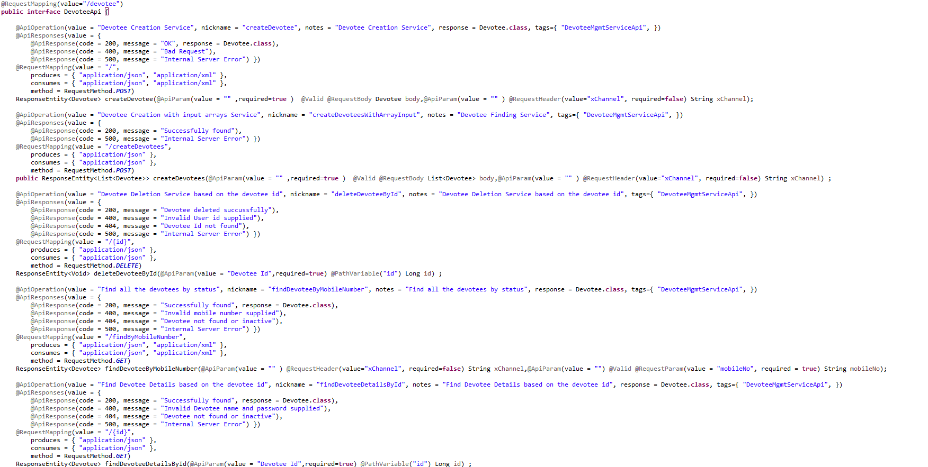

DevoteeApiController

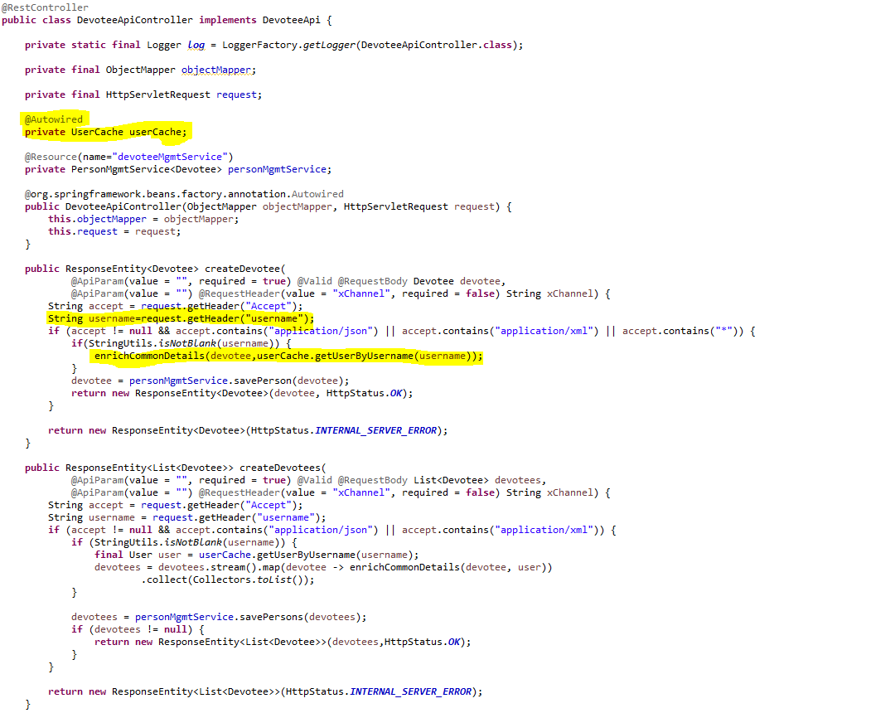

* + MemberApi and MemberApiController

MemberApi

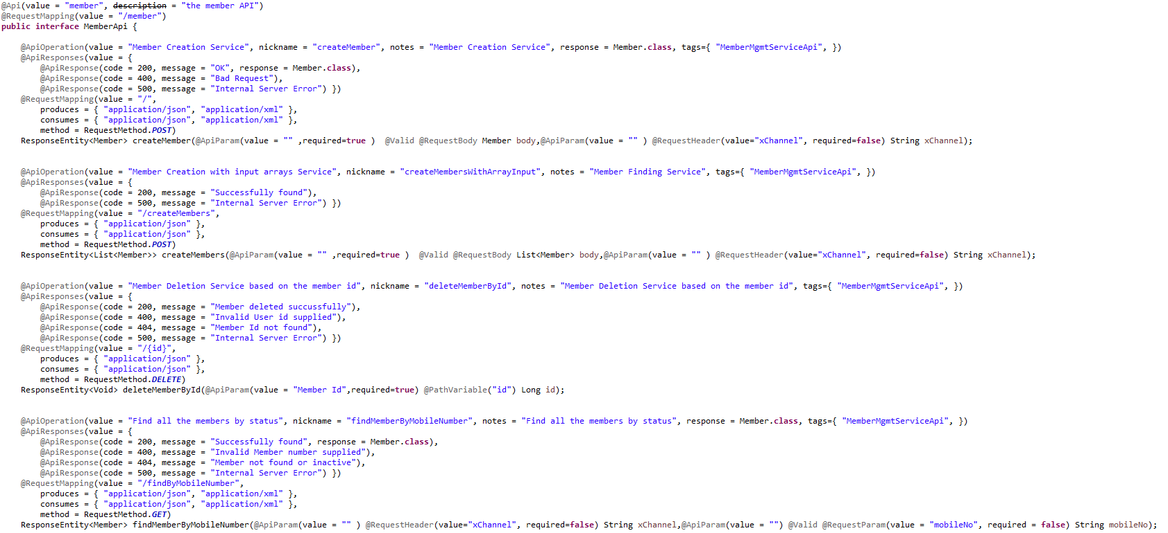

MemberApiController

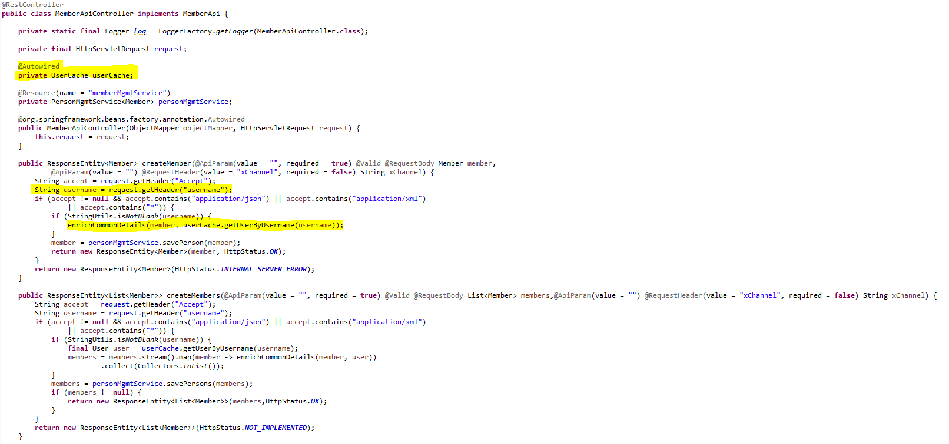

* + SevadarApi and SevadarApiController

SevadarApi

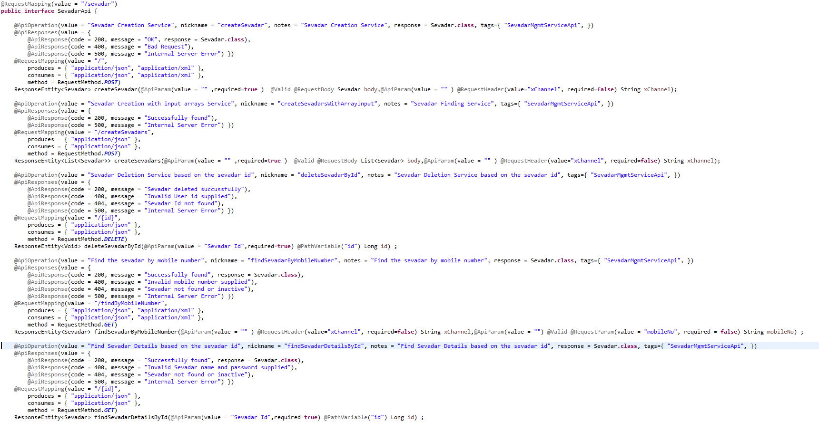

SevadarApiController

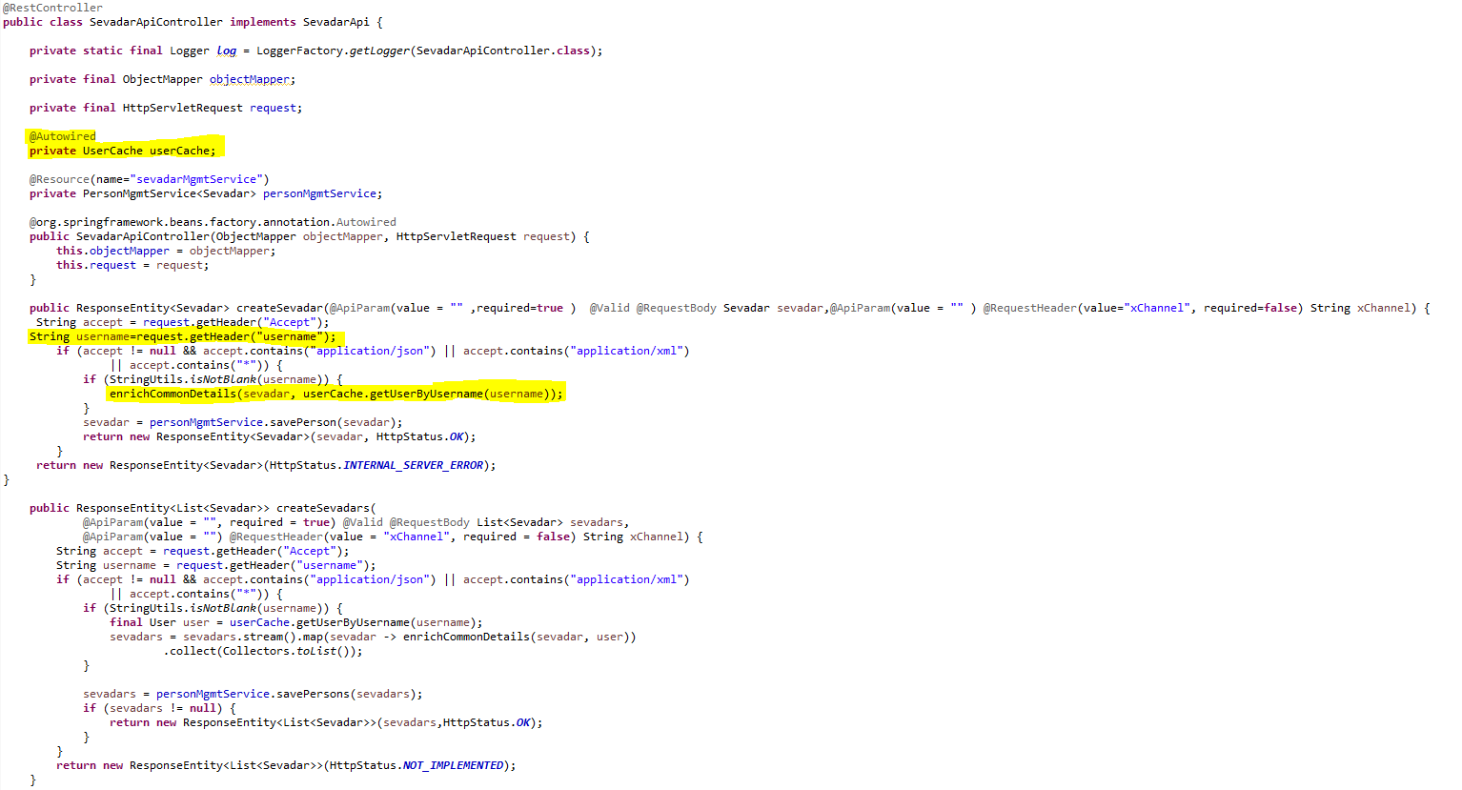

* Service should be exposed as following:

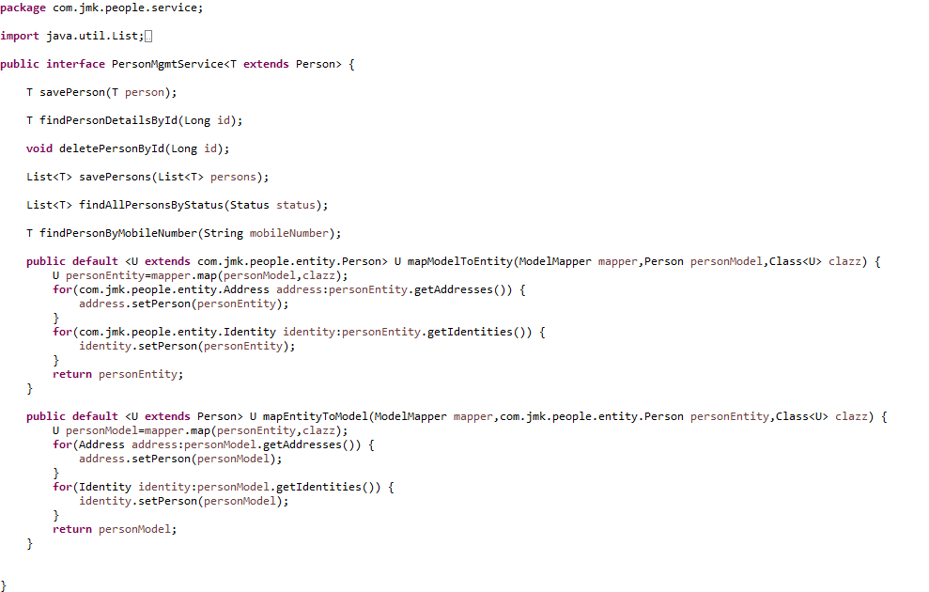

* Custom Exception Handling where EntityNotFoundException class (created in common-service) thrown if entity not present in database which is handled in RestExcceptionHandler(created in common-service), in this handler we are creating the appropriate error message in json and send back to client.

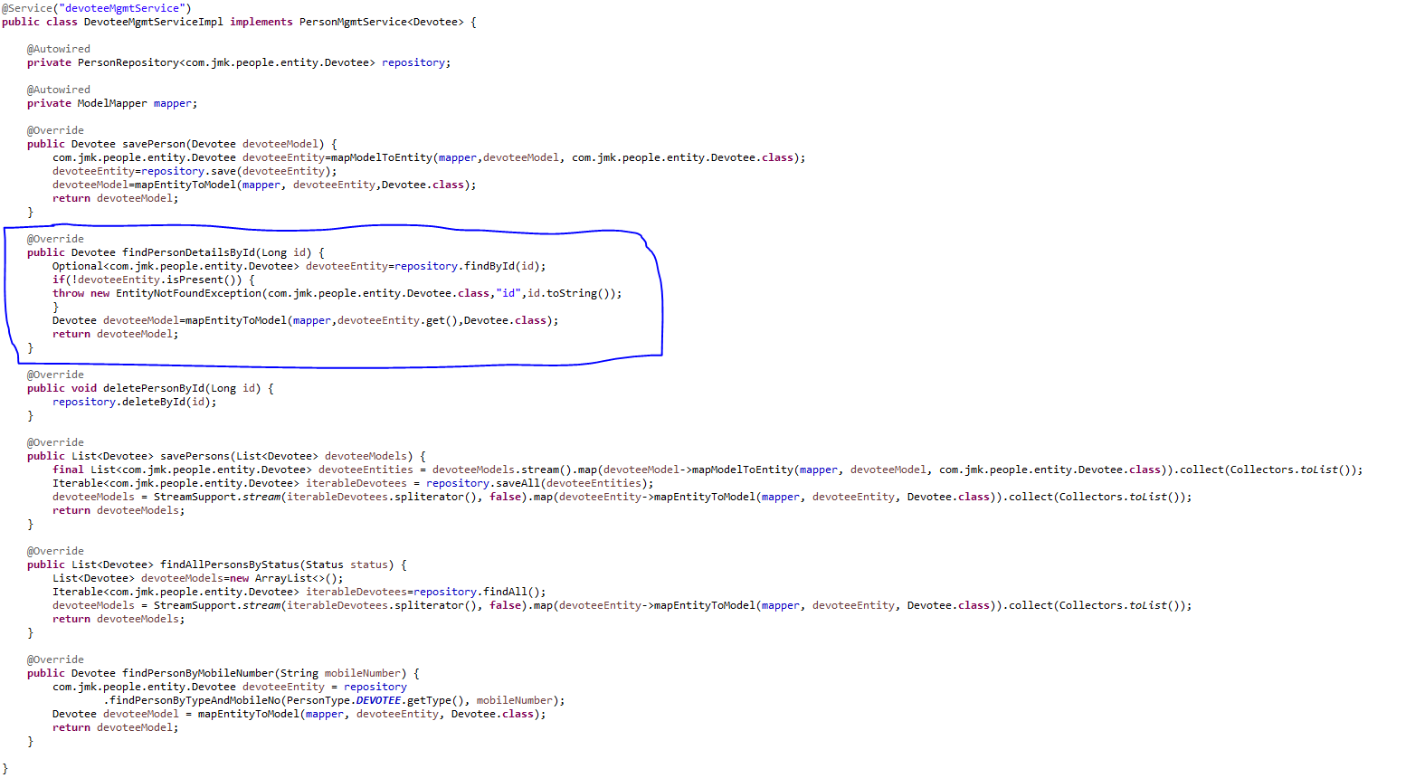

* Made changes in the SwaggerDocumentationConfig

@Configuration

**public** **class** SwaggerDocumentationConfig {

ApiInfo apiInfo() {

**return** **new** ApiInfoBuilder()

.title("People Management Service API")

.description("No description provided (generated by Swagger Codegen https://github.com/swagger-api/swagger-codegen)")

.license("")

.licenseUrl("http://unlicense.org")

.termsOfServiceUrl("")

.version("18.10.0")

.contact(**new** Contact("","", ""))

.build();

}

@Bean

**public** Docket customImplementation(){

**return** **new** Docket(DocumentationType.***SWAGGER\_2***)

.select()

.apis(RequestHandlerSelectors.*basePackage*("com.jmk.people.api")).paths(PathSelectors.*regex*("/\*.\*"))

.build()

.directModelSubstitute(org.threeten.bp.LocalDate.**class**, java.sql.Date.**class**)

.directModelSubstitute(org.threeten.bp.OffsetDateTime.**class**, java.util.Date.**class**)

.apiInfo(apiInfo());

}

}

* Made changes in the Swagger’s HomeController

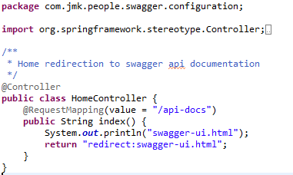

* After running the application, should be visible following functions for the following url: <http://localhost:6379/api/people-mgmt-service/swagger-ui.html>

Or

<http://localhost:6379/api/people-mgmt-service/api-docs>



* Test the People Api using JUnit



* Run the application as **Spring Boot App** in the following order
  + EurekaServerApplication
  + UserMgmtRestApplication
  + AuthServiceApplication
  + ZuulGatewayApplication
  + PeopleMgmtRestApplication
* Open the browser of Eureka Server at localhost:8761, you should see the all the microservices running and enter the url: <http://localhost:8761/>



* Testing
  + Without authentication means directly hitting the people-mgmt-project running on 6379 and fetch the member details based on the id



* + Without authentication means directly hitting the people-mgmt-project running on 6379 but not able to get the member id because it does not exist



* + With authentication means every request to people-mgmt-service microservice will be hit via gateway running 1379
    - with authentication means every request to people-mgmt-service microservice will be hit via gateway running on 1379
      * getting member details based on the id but without token means no authorization code (Bearer token) in the header will give the error.



* getting member details based on the id with token means authorization code(Bearer token) in the header will be provided using authentication service
  + 1. **To get authentication code in response header using authentication service**



* + 1. **Now hit the people-mgmt-service to** get member details based on the id by providing the token means authorization code (Bearer token) in the header received in above step



## **Account-Mgmt-Service**

Create the account-mgmt-service application as microservice with the following functionalities:

* Manage the donations
  + Saving the donation

1. Validate the donor if donor id and donor type is provided in the request. Or If donor is Devotee and its id does not exist in the request.
2. Validate the project exists.
3. Donation request is valid otherwise error message should be triggered for the user.
4. Creating the donor if required: If donor is devotee and its id does not exist it means we need to create the devotee record first then will save the donation.
5. Saving the donation.
   * Updating the donation
   * Find the donation based on the id
   * Delete the donation
   * Saving the donation in bulk

* Manage the expenses:
  + Saving the expense
    1. Validate the project exists.
  + Saving the expense in bulk
  + Updating the expense
  + Delete the expense
  + Find the expense by id

After that made the following changes:



Follow the document to implement project-mgmt-service: **DemoProjectWork-member-mgmt-service.doc** along with the following changes:

|  |  |
| --- | --- |
| Database/Schema Name | account\_db |
| User name | bjjd |
| Password | bjjd\_379 |

**Commands:**

Connect with the root with the following credentials in MySQL database command line or UI

User Id: root

Password: bjjd

* create database account\_db;
* create user 'bjjd'@'%' identified by 'bjjd\_379';
* grant all on account\_db.\* to 'bjjd'@'%';
* Use the following document related to the swagger, database scripts, ER diagram of Users:

  

* Move the following maven dependency from project-mgmt-service to common-service to make it centralize and create the bean in common service for these features so that these can be used in various microservices.



* Add the following dependencies in pom.xml with the following considerations:
  + Spring Cloud Starter Config: This dependency is required to connect to the Config Server
  + Spring Boot Starter Parent: update the version: 2.2.4.RELEASE highlighted in yellow colour.
  + Spring Cloud version: upgraded to Hoston.SR4. It is highlighted in yellow colour.
  + Maven Jar Plugin Version: After the above updates, pom is giving compiler error in pom.xml so downgraded version of maven jar plugin to 3.1.1. It is highlighted in yellow colour.

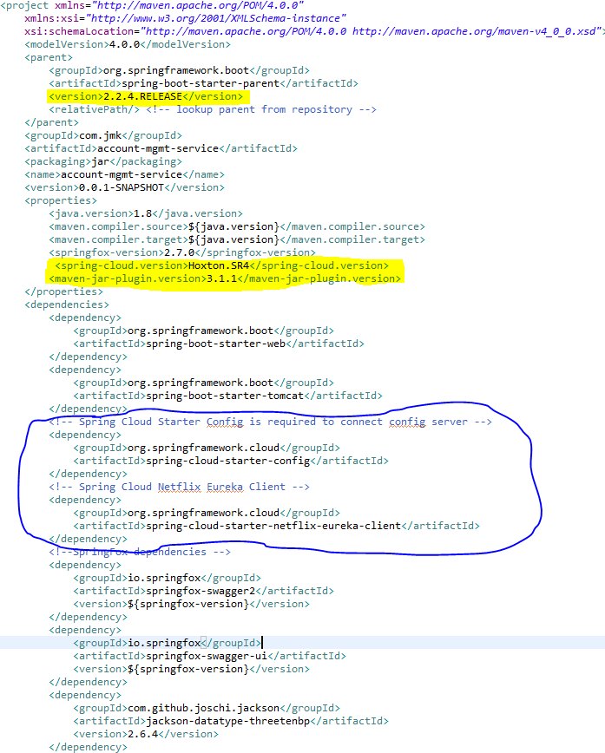

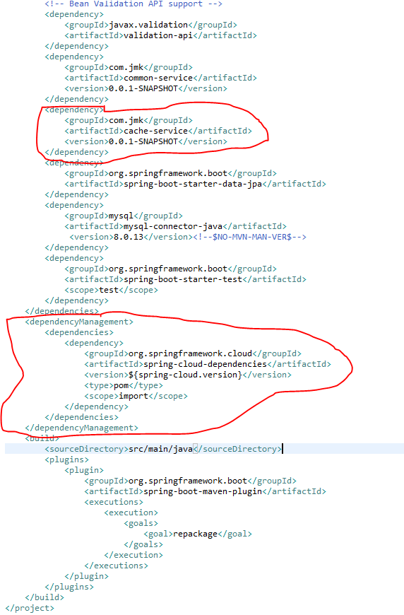

* Rename the package of io.swagger to com.jmk.account
* Rename and refactor the Swagger2SpringBoot.java to AccountMgmtRestApplication.java with the following details:
  + Enable Eureka Client so that it can be register with Eureka Server
  + Enable JpaRepositories
  + Enable FeignClient to interact with user-mgmt-service, people-mgmt-service, project-mgmt-service etc.
  + Enable EnableSwagger2 so that we can view the document api

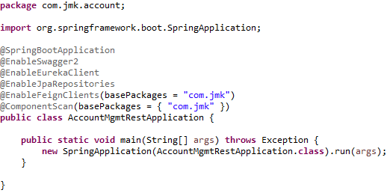

* Moved the following main application.properties along with different profiles to git repository: **bjjd-config-server-git-repo**

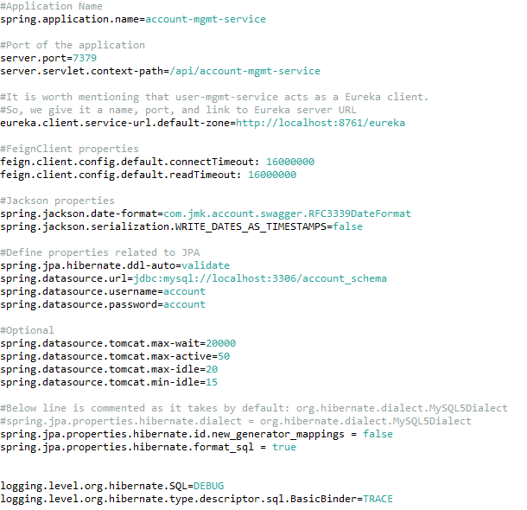

* In this application, still there will be an application.properties file but it will have the following minimum details:
  + Name of the application
  + Active Default Profile
  + Cloud Config server URI with port

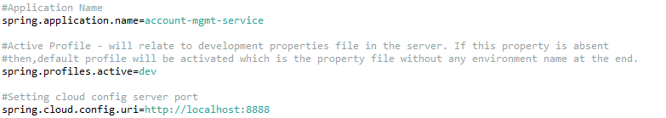

* Create the DonationApi and DonationApiController Class
* DonationApi interface

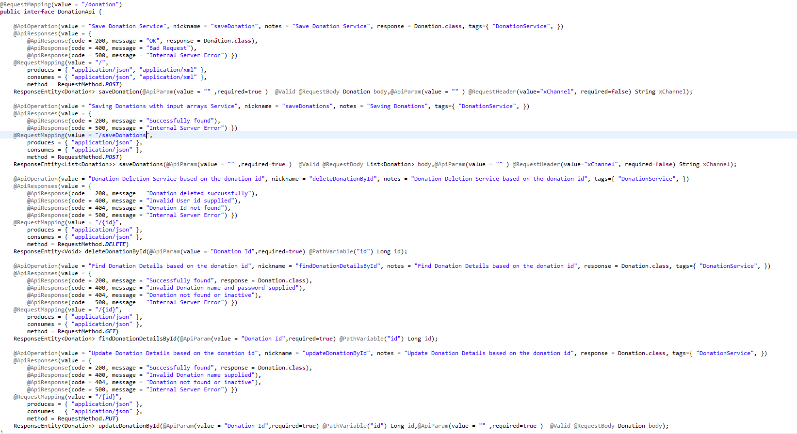

* DonationApiController Class: In this class, when saving donation, we will perform the following activities:
* Validate the donor if donor id and donor type is provided in the request. Or If donor is Devotee and its id does not exist in the request.
* Validate the project exists.
* Donation request is valid otherwise error message should be triggered for the user.
* Creating the donor if required: If donor is devotee and its id does not exist it means we need to create the devotee record first then will save the donation.
* Saving the donation.

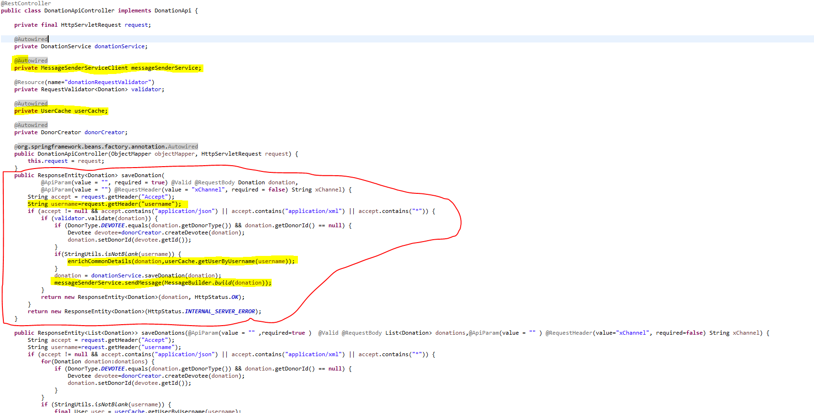

* Create the ExpenseApi and ExpenseApiController Class
* ExpenseApi

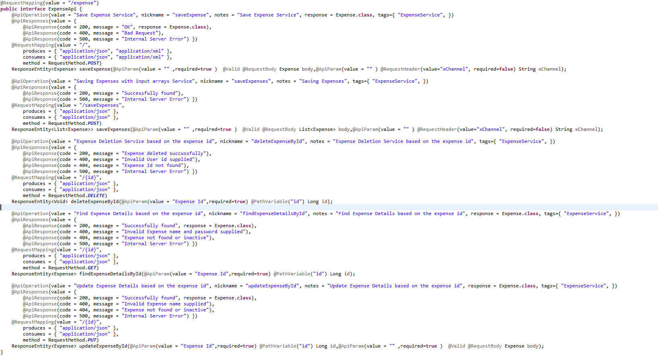

* ExpenseApiController Class: during the saving expense, validating the project.

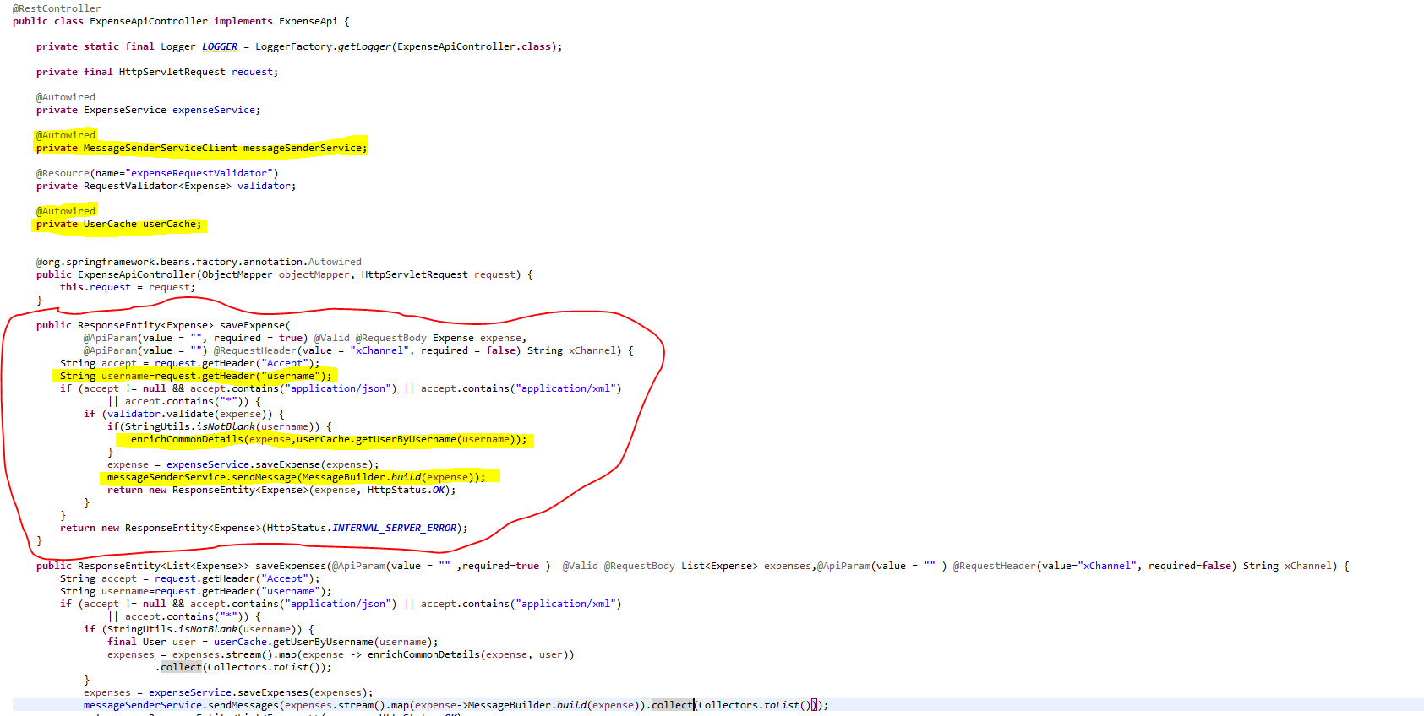

* Create the feign client to interact with people-mgmt-service and project-mgmt-service.
* PeopleMgmtServiceClient

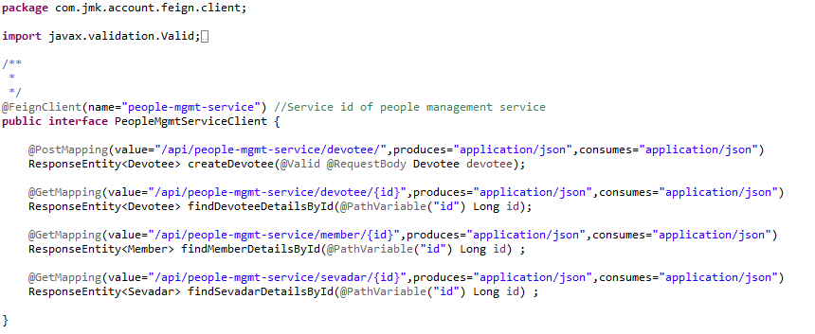

* ProjectMgmtServiceClient

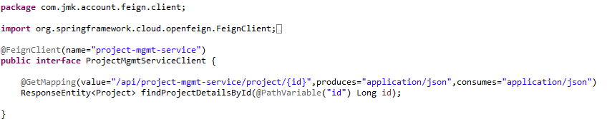

* **MessageSenderServiceClient**: to interact with message-sender-service to send the message to visitor.

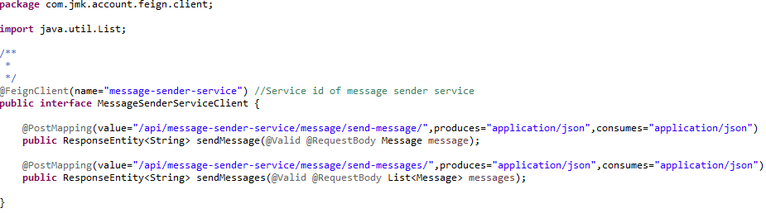

* Custom Exception Handling where
  + **EntityNotFoundException :** While interacting with people-mgmt-service and project-mgmt-service to validate the entity using feign client, EntityNotFoundException class (created in common-service) can be thrown if entity not present in database which is handled in RestExceptionHandler(created in common-service), But we are not able to catch this EntityNotFoundException exception from caller microservice as it throws FeignException so to catch the appropriate exception, need to handle this in FeignExceptionHandler class (created in common-service) we are creating the appropriate error message in json and send back to client.
  + **StatusNotFoundException:** This exception can be thrown when entity is present but its status is not active and it is handled in

RestExceptionHandler(created in common-service).

* Create the **RequestValidator** to validate the donation and expense request where we will validate the donor and project by invoking the people-mgmt-service and project-mgmt-service using feign client.

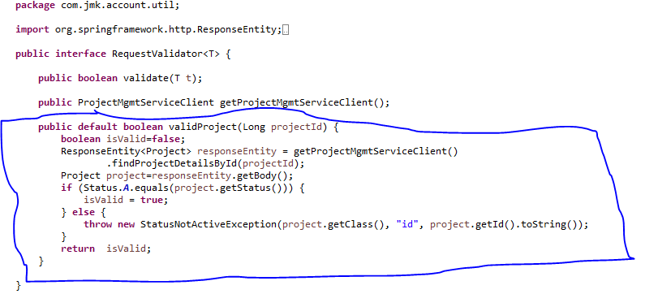

DonationRequestValidator implements RequestValidator where we are validating the donation request:

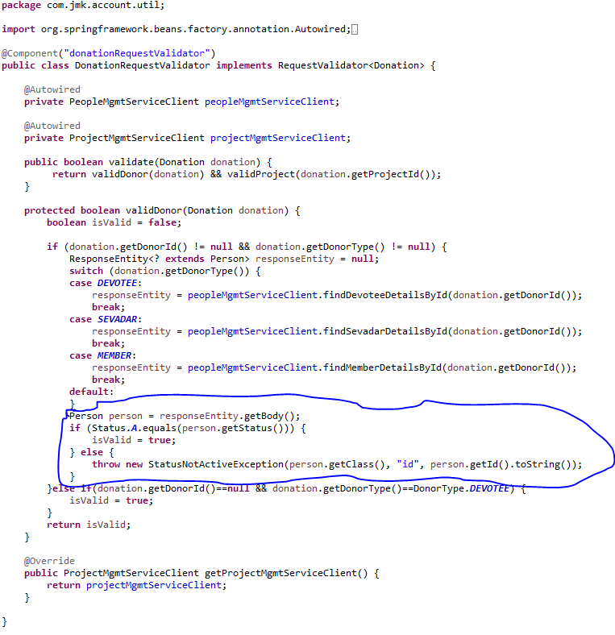

ExpenseRequestValidator implements RequestValidator where we are validating the donation request:



* Create DonorCreator class to create the donor by invoking the people-mgmt-service using feign client.

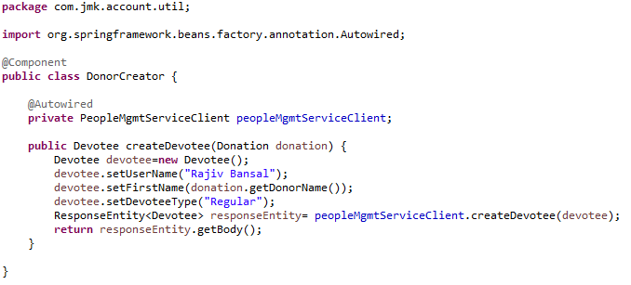

* DonationService and DonationServiceImpl Class should be exposed as following:
* DonationService interface



* DonationServiceImpl interface



* ExpenseService and ExpenseServiceImpl Class should be exposed as following:
* ExpenseService



* ExpenseServiceImpl



* Made changes in the SwaggerDocumentationConfig



* Made changes in the Swagger’s HomeController



* After running the application, should be visible following functions for the following url: <http://localhost:7379/api/account-mgmt-service/swagger-ui.html>

Or

<http://localhost:7379/api/account-mgmt-service/api-docs>



* Test the DonationApiTest using Junit



* Run the application as **Spring Boot App** in the following order
  + EurekaServerApplication
  + UserMgmtRestApplication
  + AuthServiceApplication
  + ZuulGatewayApplication
  + PeopleMgmtRestApplication
  + ProjectMgmtRestApplication
  + AccountMgmtRestApplication
* Open the browser of Eureka Server at localhost:8761, you should see the all the microservices running and enter the url: <http://localhost:8761/>



* Testing
  + Without authentication means directly hitting the account-mgmt-project running on 7379 and save the donation details



* + Without authentication means directly hitting the account-mgmt-project running on 7379 but member does not exist for whom we are saving the donation is not active.



* + With authentication means every request to people-mgmt-service microservice will be hit via gateway running 1379
    - with authentication means every request to people-mgmt-service microservice will be hit via gateway running on 1379
      * getting member details based on the id but without token means no authorization code (Bearer token) in the header will give the error.



* Saving donation with token means authorization code (Bearer token) in the header will be provided using authentication service
  + 1. **To get authentication code in response header using authentication service**



* + 1. **Now hit the account-mgmt-service to** save the donation by providing the token means authorization code (Bearer token) in the header received in above step
  + See the **Authorization** tab in the donation request



* + See the **Body** tab in the donation request and response can be seen.



## **Darshan Mgmt Service**

Create the darshan-mgmt-service application as microservice with the following functionalities:

* Saving the details of darshan which includes the Darshan Date, Visitor Details, number of members with Visitor, number of times he visited
  + Validate the visitor if visitor id and donor type is provided in the request. Or If donor is Devotee and its id does not exist in the request.
  + Darshan request is valid otherwise error message should be triggered for the user.
  + Creating the visitor if required: If visitor is devotee and its id does not exist it means we need to create the devotee record first then will save the donation.
  + Saving the donation.
  + Saving the details of darshan in bulk
  + Updating the darshan details
  + Delete the darshan
  + Find the darshan by id

After that made the following changes:



Follow the document to implement project-mgmt-service: **DemoProjectWork-member-mgmt-service.doc** along with the following changes:

|  |  |
| --- | --- |
| Database/Schema Name | darshan\_db |
| User name | bjjd |
| Password | bjjd\_379 |

**Commands:**

Connect with the root with the following credentials in MySQL database command line or UI

User Id: root

Password: bjjd

* create database darshan\_db;
* create user 'bjjd'@'%' identified by 'bjjd\_379';
* grant all on darshan\_db.\* to 'bjjd'@'%';
* Use the following document related to the swagger, database scripts, ER diagram of Users:



* Move the following maven dependency from darshan-mgmt-service to common-service to make it centralize and create the bean in common service for these features so that these can be used in various microservices.



* Add the following dependencies in pom.xml with the following considerations:
  + Spring Cloud Starter Config: This dependency is required to connect to the Config Server
  + Spring Boot Starter Parent: update the version: 2.2.4.RELEASE highlighted in yellow colour.
  + Spring Cloud version: upgraded to Hoston.SR4. It is highlighted in yellow colour.
  + Maven Jar Plugin Version: After the above updates, pom is giving compiler error in pom.xml so downgraded version of maven jar plugin to 3.1.1. It is highlighted in yellow colour.

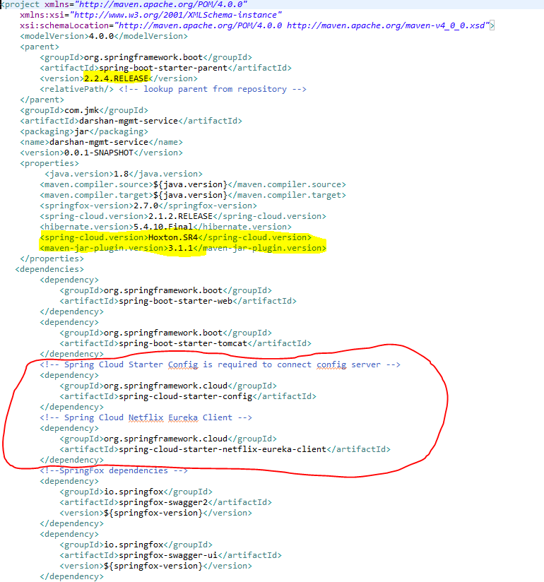

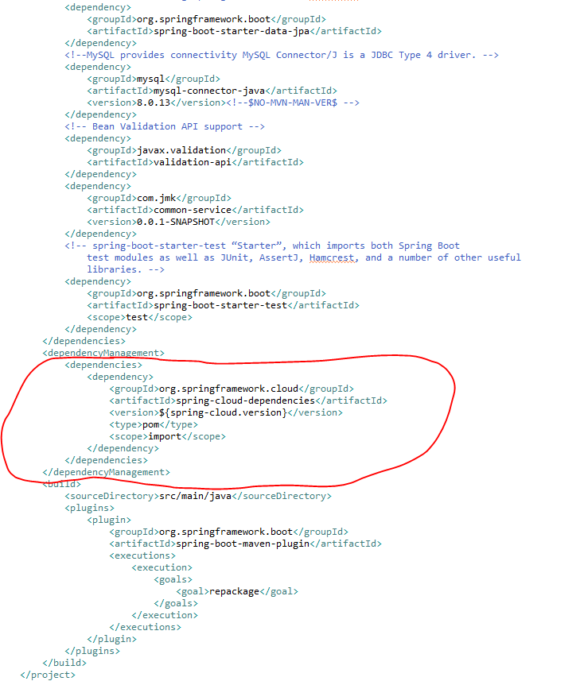

* Rename the package of io.swagger to com.jmk. darshan
* Rename and refactor the Swagger2SpringBoot.java to DarshanMgmtRestApplication.java with the following details:
  + Enable Eureka Client so that it can be register with Eureka Server
  + Enable JpaRepositories
  + Enable FeignClient to interact with user-mgmt-service, people-mgmt-service.
  + Enable EnableSwagger2 so that we can view the document api

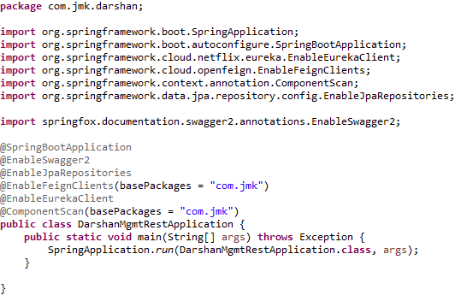

* Moved the following main application.properties along with different profiles to git repository: **bjjd-config-server-git-repo**

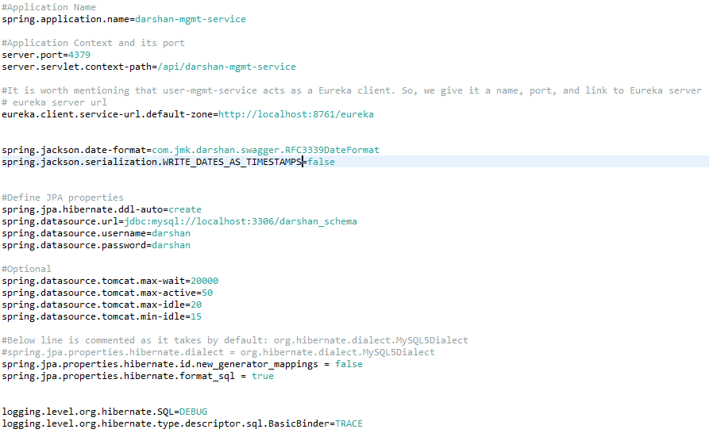

* In this application, still there will be an application.properties file but it will have the following minimum details:
  + Name of the application
  + Active Default Profile
  + Cloud Config server URI with port

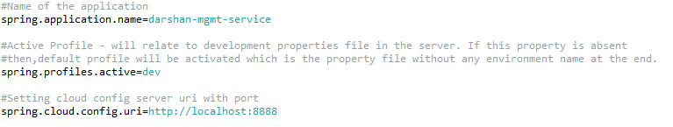

* Create the DarshanApi and DarshanApiController Class
* DarshanApi interface

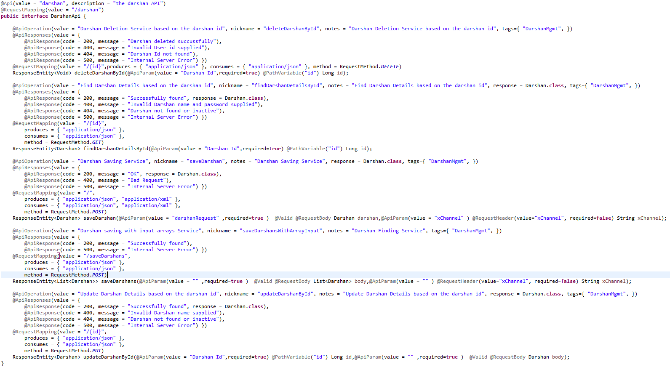

* DarshanApiController Class

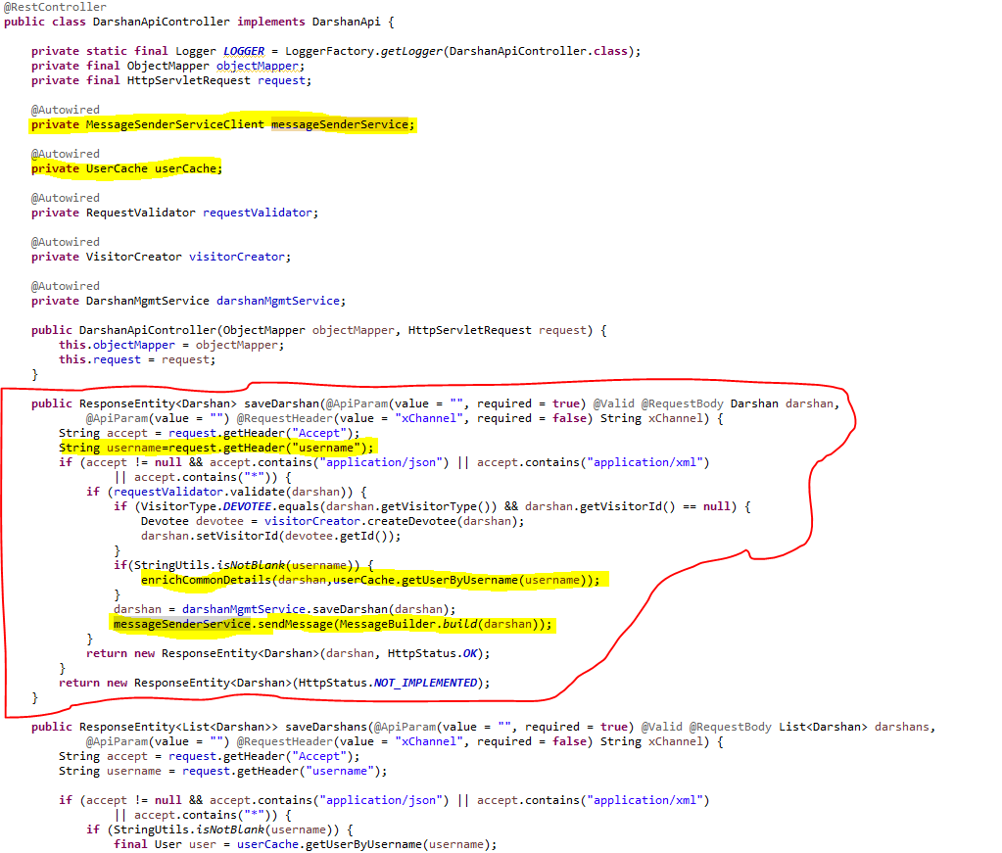

* Create the feign client to interact with people-mgmt-service to get the details of devotee, member and sevadar.
  + **PeopleMgmtServiceClient**: to interact with people-mgmt-service to get the details of devotee, member and sevadar.



* **MessageSenderServiceClient**: to interact with message-sender-service to send the message to visitor.

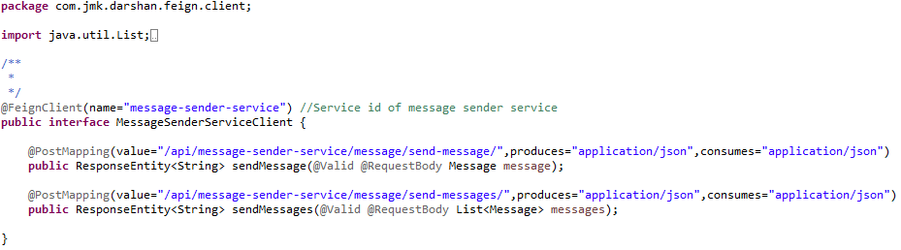

* Custom Exception Handling where
  + **EntityNotFoundException :** While interacting with people-mgmt-service to validate the entity using feign client, EntityNotFoundException class (created in common-service) can be thrown if entity not present in database which is handled in RestExceptionHandler(created in common-service), But we are not able to catch this EntityNotFoundException exception from caller microservice as it throws FeignException so to catch the appropriate exception, need to handle this in FeignExceptionHandler class (created in common-service) we are creating the appropriate error message in json and send back to client.
  + **StatusNotFoundException:** This exception can be thrown when entity is present but its status is not active and it is handled in

RestExceptionHandler(created in common-service).

* Create the **RequestValidator** to validate the darshan request where we will validate the visitor by invoking the people-mgmt-service using feign client.

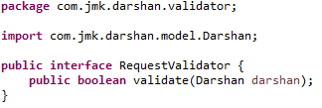

DarshanRequestValidator implements RequestValidator where we are validating the darshan request:

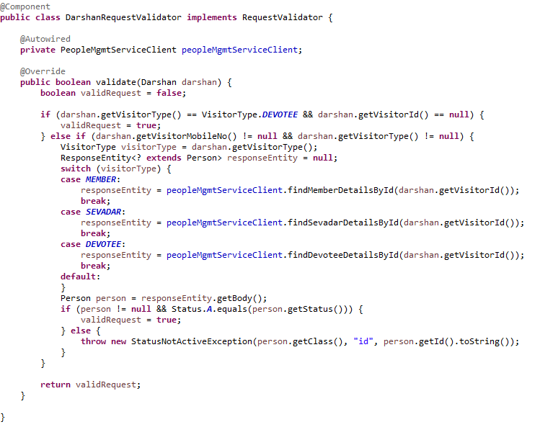

* Create VisitorCreator class to create the donor by invoking the people-mgmt-service using feign client.

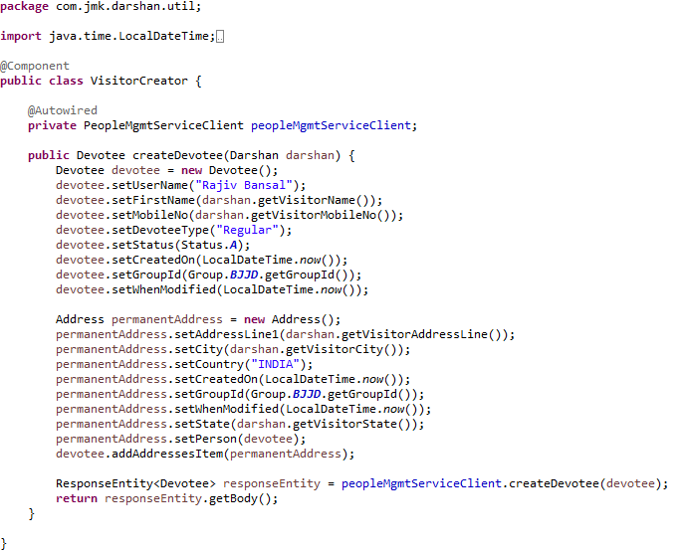

* DarshanMgmtService and DarshanMgmtServiceImpl Class should be exposed as following:
* DarshanMgmtService interface

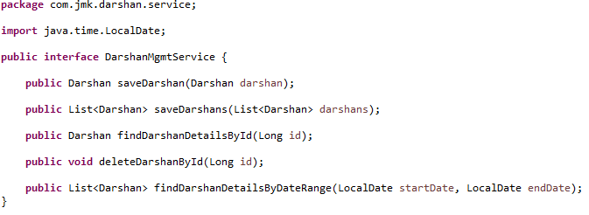

* DarshanMgmtServiceImpl interface

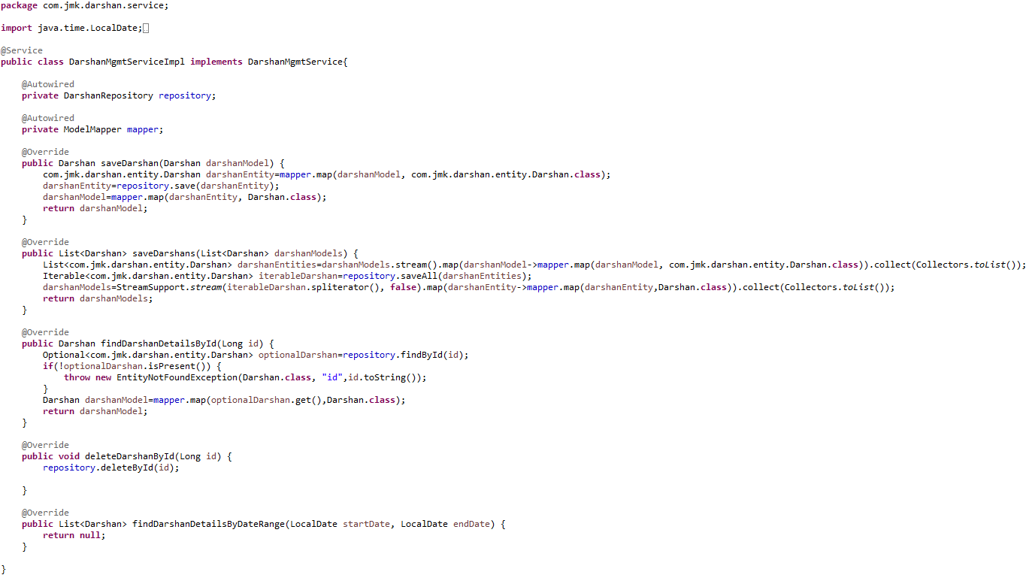

* Made changes in the hightlighted yellow in SwaggerDocumentationConfig

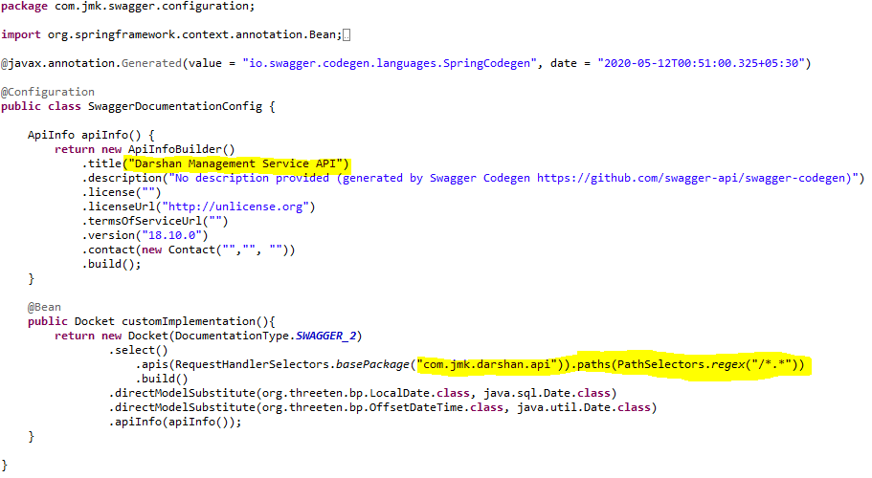

* Made changes in the Swagger’s HomeController

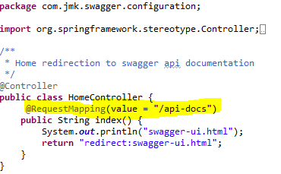

* After running the application, should be visible following functions for the following url: <http://localhost:4379/api/darshan-mgmt-service/swagger-ui.html>

Or

<http://localhost:4379/api/darshan-mgmt-service/api-docs>

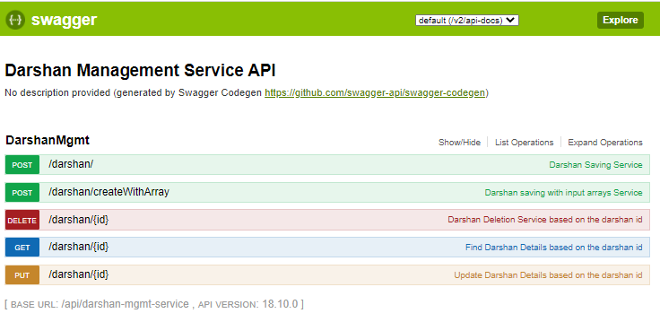

* Test the DarshanApiTest using Junit

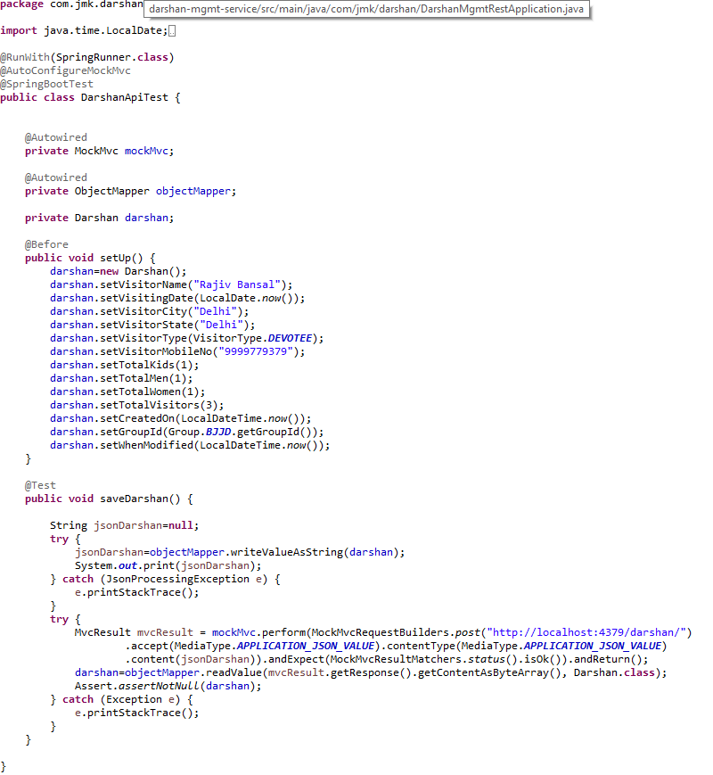

* Run the application as **Spring Boot App** in the following order
  + ConfigServerApplication
  + EurekaServerApplication
  + UserMgmtRestApplication
  + AuthServiceApplication
  + ZuulGatewayApplication
  + PeopleMgmtRestApplication
  + DarshanMgmtRestApplication
* Open the browser of Eureka Server at localhost:8761, you should see the all the microservices running and enter the url: <http://localhost:8761/>

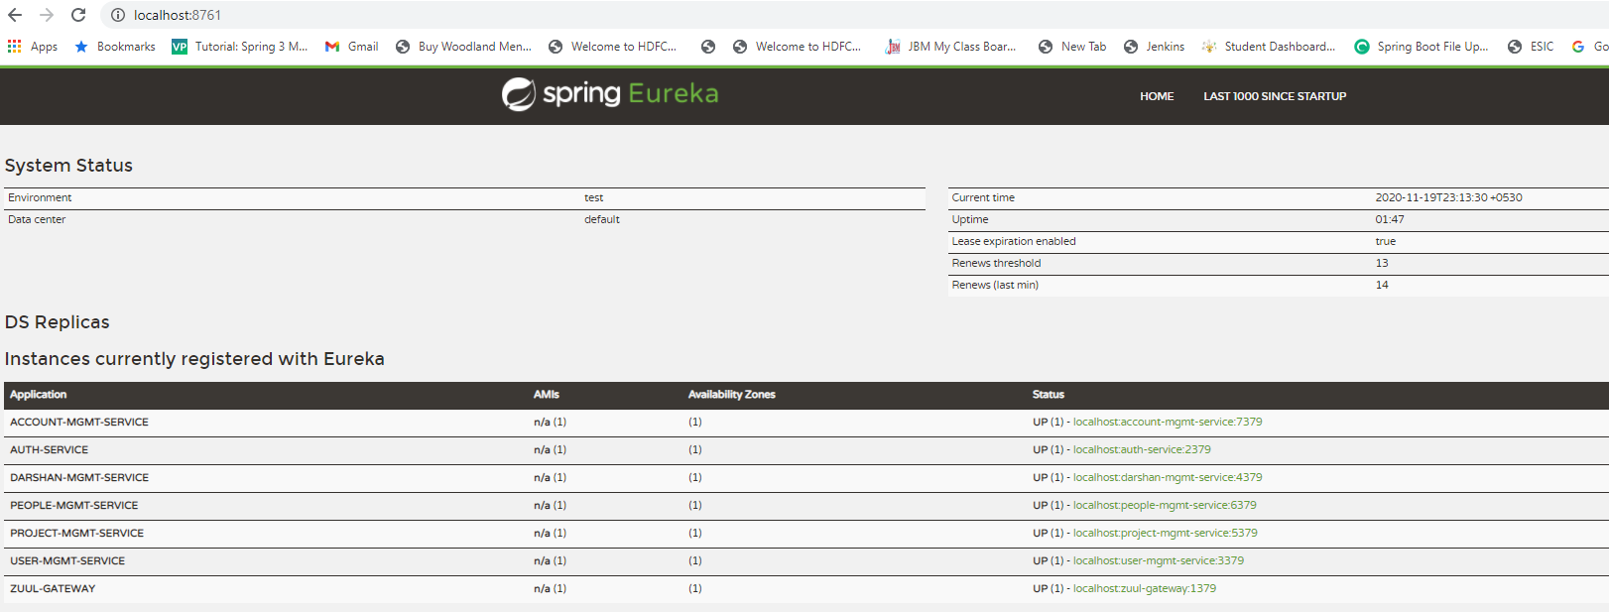

* Testing
  + Without authentication means directly hitting the darshan-mgmt-service running on 4379 and save the darshan details

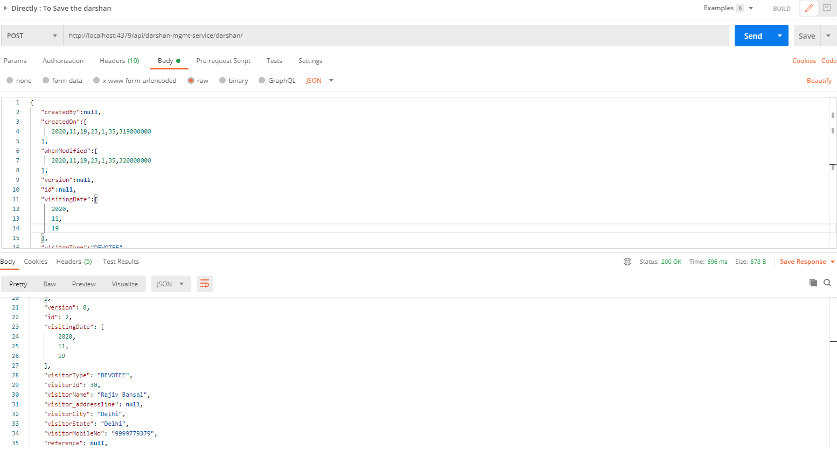

* + With authentication means every request to darshan-mgmt-service microservice will be hit via gateway running 1379
    - with authentication means every request to darshan-mgmt-service microservice will be hit via gateway running on 1379
      * saving darshan details based on the id but without token means no authorization code (Bearer token) in the header will give the error.

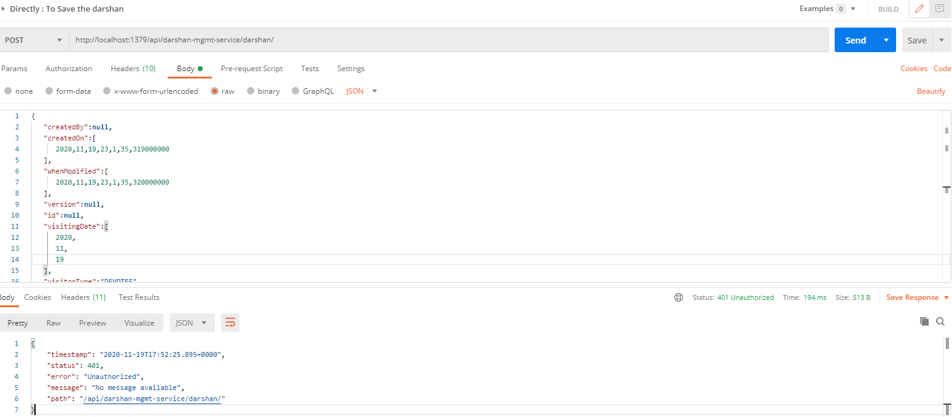

* Saving darshan with token means authorization code (Bearer token) in the header will be provided using authentication service
  + 1. **To get authentication code in response header using authentication service**

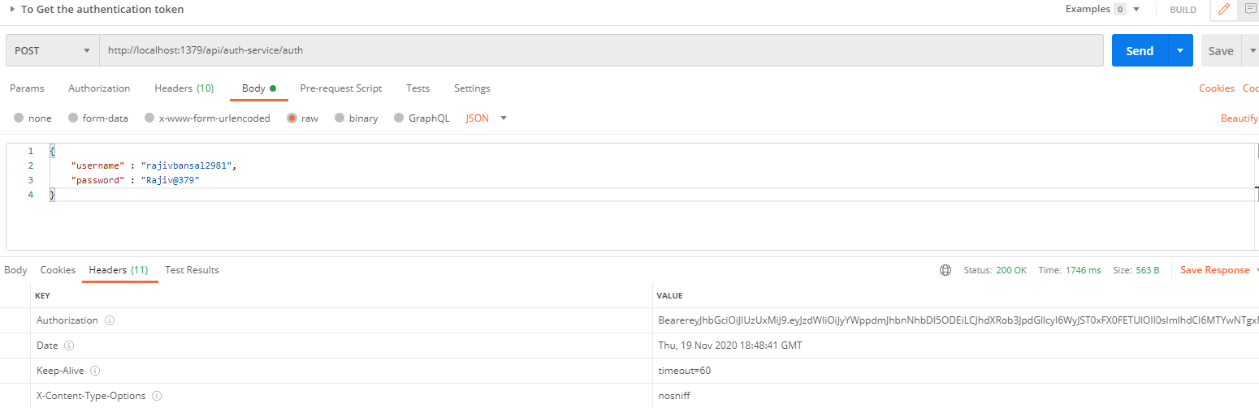

* + 1. **Now hit the darshan-mgmt-service to** save the donation by providing the token means authorization code (Bearer token) in the header received in above step
  + See the **Authorization** tab in the darshan request

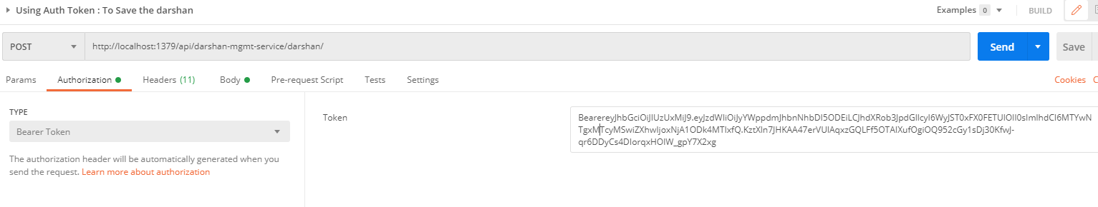

* + See the **Body** tab in the darshan request and response can be seen.

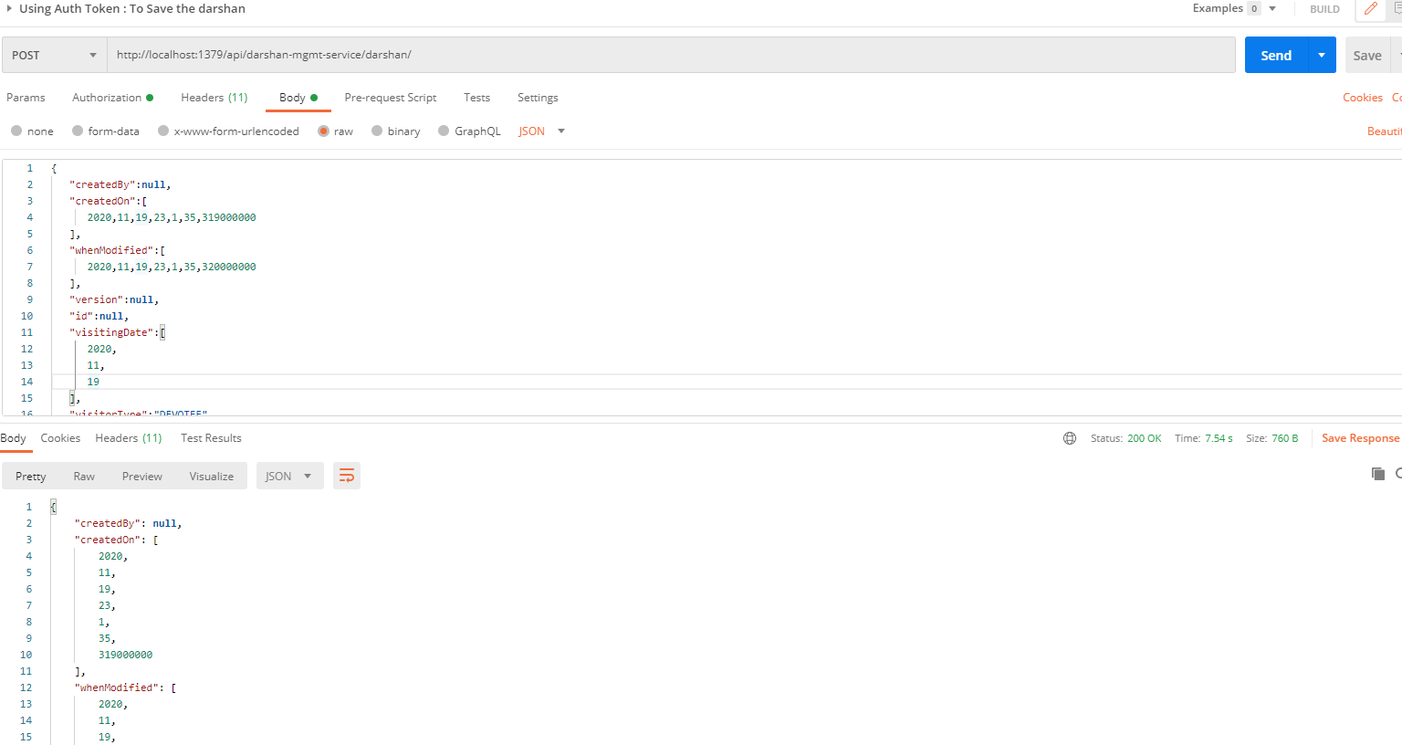

## **Data-Upload-Service**

This service will upload the data in bulk for Donations, Expenses, Darshan, Member, Devotee etc. in different format and call the appropriate microservice to save the data.

* Create the Project using spring Starter Project.



* Click on Next and select the Spring Web Module.

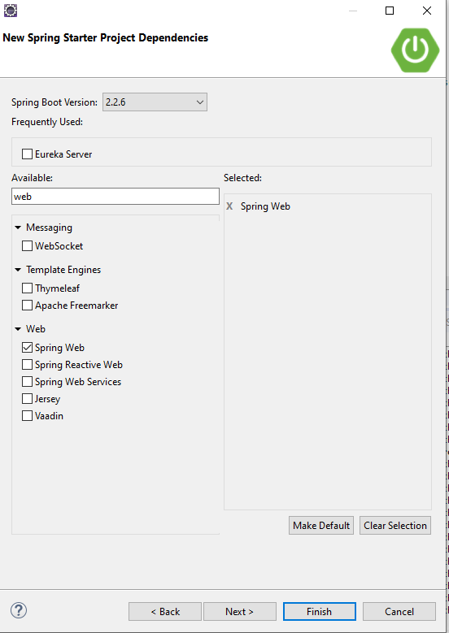

* Click on Finish and import the project.



* Add the following dependencies in pom.xml with the following considerations:
  + Spring Cloud Starter Config: This dependency is required to connect to the Config Server
  + Spring Boot Starter Parent: update the version: 2.2.4.RELEASE highlighted in yellow colour.
  + Spring Cloud version: upgraded to Hoston.SR4. It is highlighted in yellow colour.
  + Excel File Processing API: used org.apache.poi API.
  + Cache-service and common-service: used internally created API: cache-service(to be discuss in next section) to cache the reference entities and common-service to use the model and utility classes.
  + Maven Jar Plugin Version: After the above updates, pom is giving compiler error in pom.xml so downgraded version of maven jar plugin to 3.1.1. It is highlighted in yellow colour.

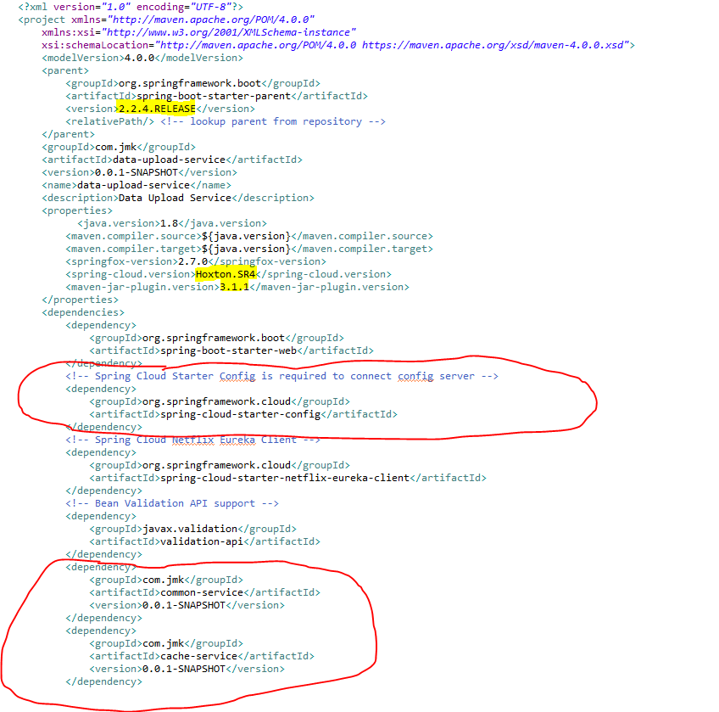

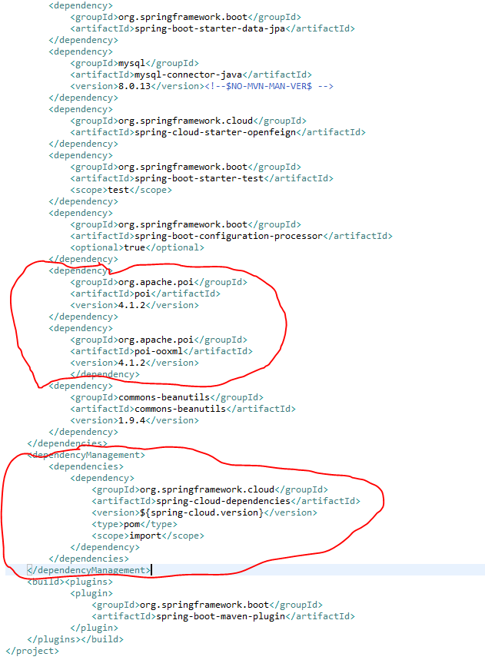

* **Update the main DataUploadServiceApplication application with the following details:**

1. Enable Eureka Client so that it can register with Eureka Server
2. Enable FeignClient to interact with people-mgmt-service, account-mgmt-service and project-mgmt-service
3. Enable JpaRepositories to store the data upload history.
4. To enable the ConfigurationProperties feature, you need to add [@EnableConfigurationProperties](https://docs.spring.io/spring-boot/docs/current/api/org/springframework/boot/context/properties/EnableConfigurationProperties.html) annotation to any configuration class.

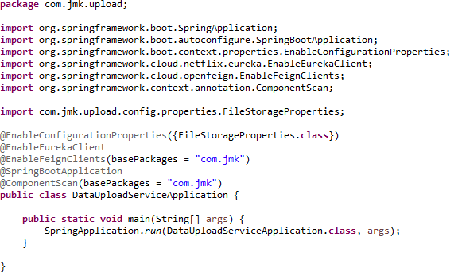

* Configuring Server and File Storage Properties

**First thing First!**

* + Let’s configure our Spring Boot application to enable Multipart file uploads, and define the maximum file size that can be uploaded. We’ll also configure the directory into which all the uploaded files will be stored.
  + Add the eureka client properties so that it can register with Eureka Server
  + Enable the feign client properties so that we can communicate with different microservices.

Open src/main/resources/application.properties file, and add the following properties to it.

* Moved the following main application.properties along with different profiles to git repository: **bjjd-config-server-git-repo**

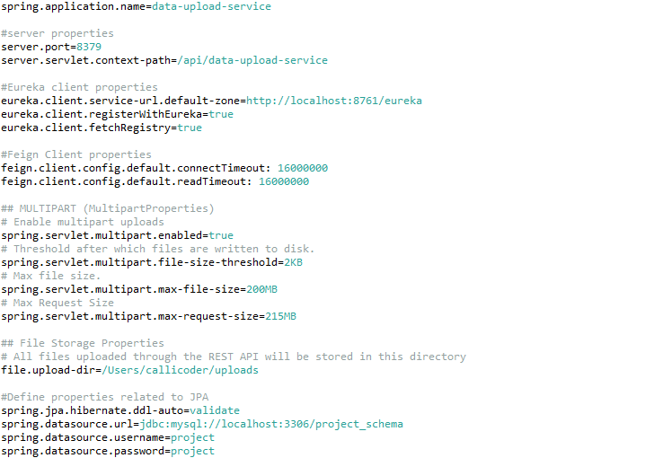

* In this application, still there will be an application.properties file but it will have the following minimum details:
  + Name of the application
  + Active Default Profile
  + Cloud Config server URI with port

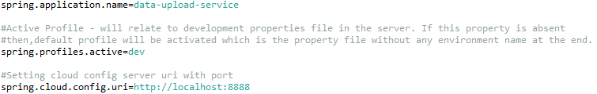

* **Automatically binding properties to a POJO class**

Spring Boot has an awesome feature called [@ConfigurationProperties](https://docs.spring.io/spring-boot/docs/current/reference/html/boot-features-external-config.html" \l "boot-features-external-config-typesafe-configuration-properties) using which you can automatically bind the properties defined in the application.properties file to a POJO class.

Let’s define a POJO class called FileStorageProperties to bind all the file storage properties.



The @ConfigurationProperties(prefix = "file") annotation does its job on application startup and binds all the properties with prefix file to the corresponding fields of the POJO class.

If you define additional file properties in future, you may simply add a corresponding field in the above class, and spring boot will automatically bind the field with the property value.

* Excel File Template(json format) to upload the excel file data in proper format so that it can be validated and processed. Basic format should be like this: excelSheetTemplate.json



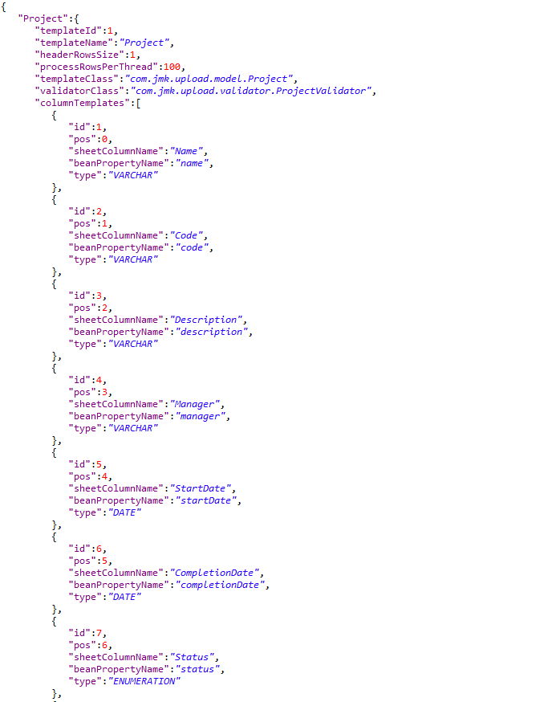

* To handle the data coming in excelFileTemplate we will have two classes:
  + ExcelSheetTemplate.java
  + ColumnTemplate.java
* ExcelSheetTemplate.java

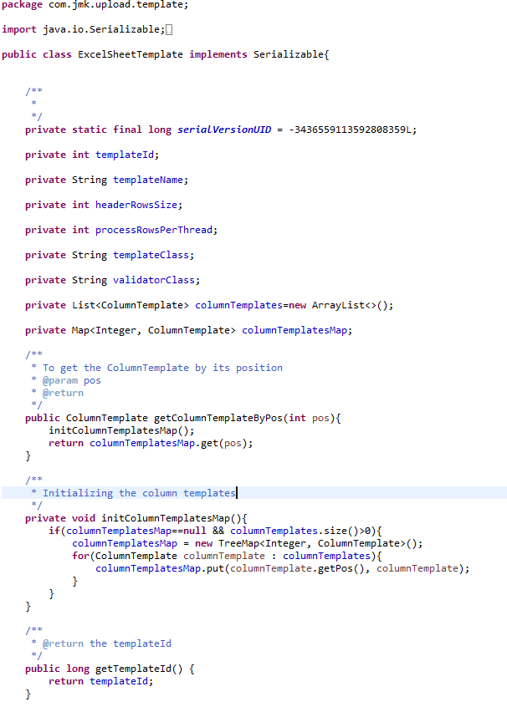

* ColumnTemplate.java

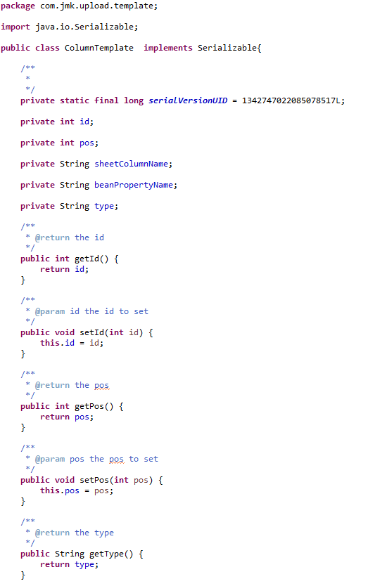

* Read Excel Sheet Template using class: ExcelSheetTemplateReader.java

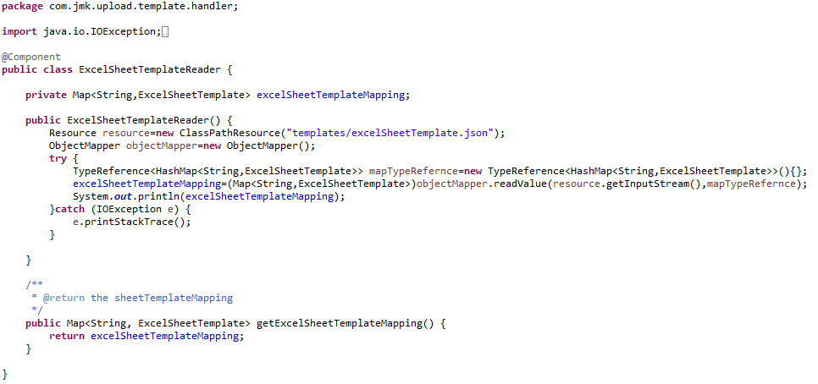

* Write REST FileUploadController to upload the single or multiple excel files from UI (Browser or Application).

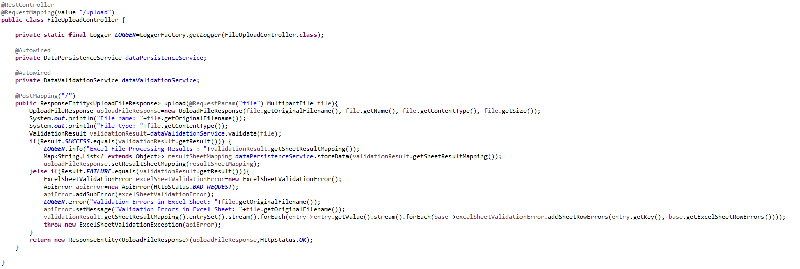

* DataValidationService Interface and its implementation class DataValidationServiceImpl to validate the uploaded excel file.
  + DataValidationService.java

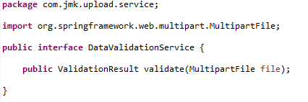

* DataValidationServiceImpl.java

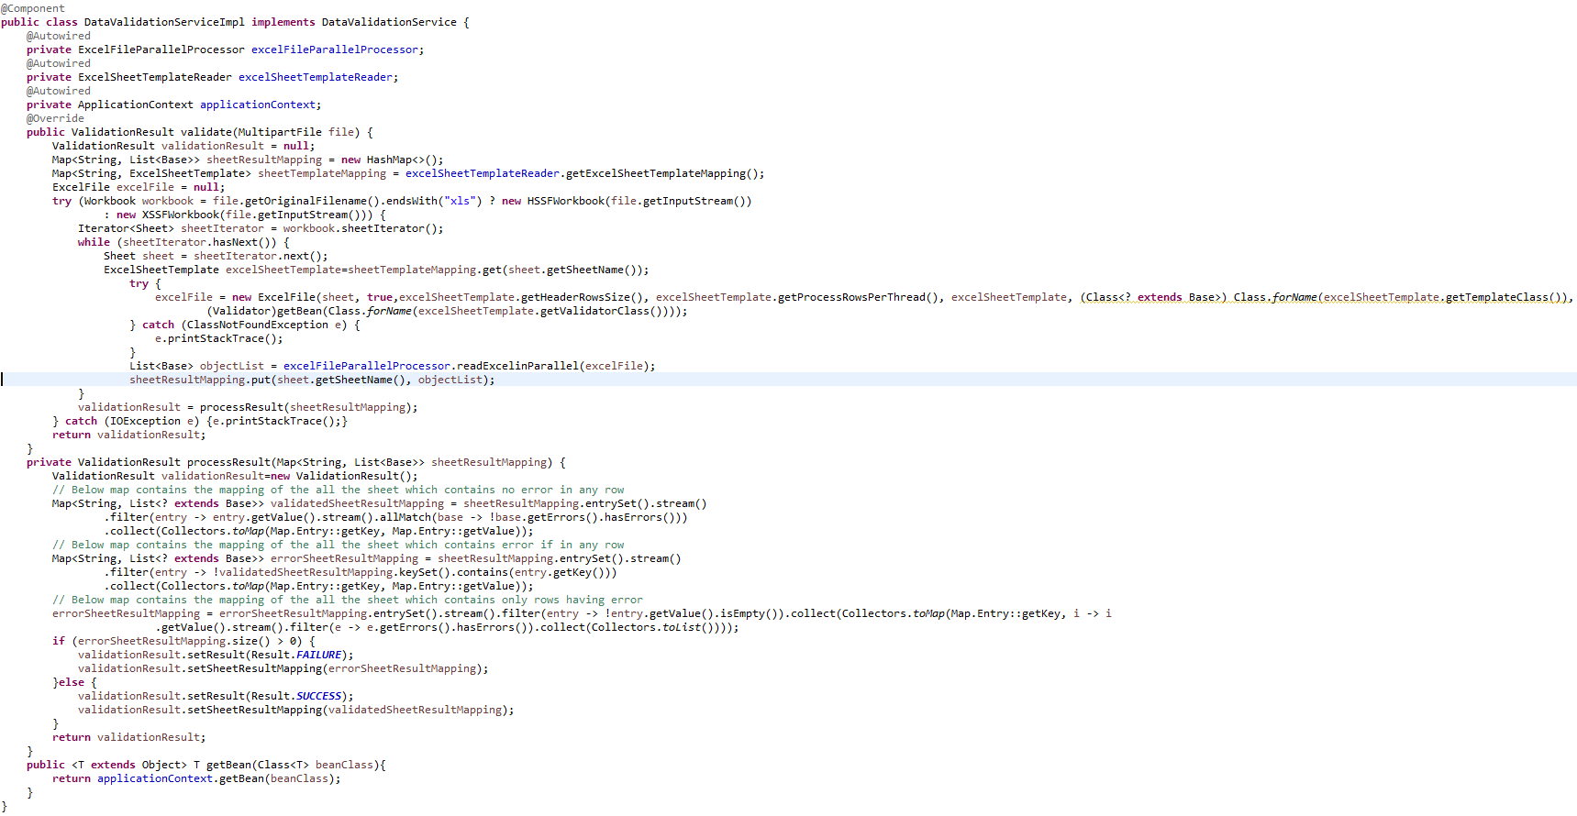

* ExcelFileParallelProcessor to process the excel file by reading the excelfile using ExcelFileReader in parallel using multithreading: ExecutorService

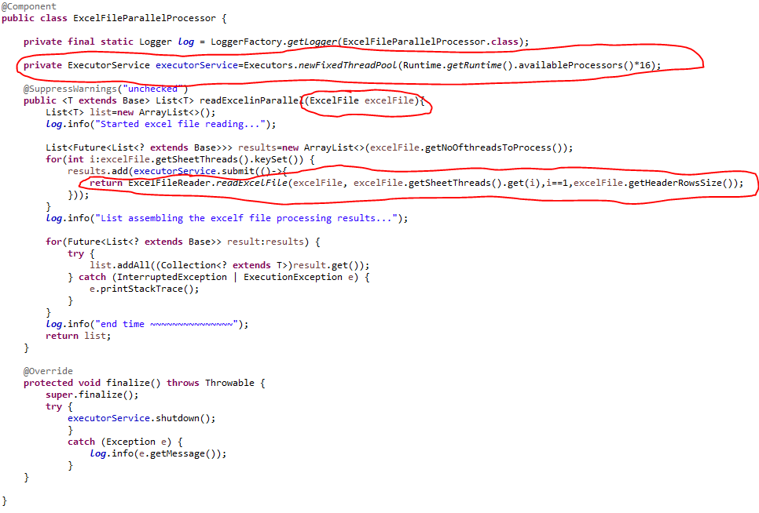

* ExcelFileReader to read the excel file

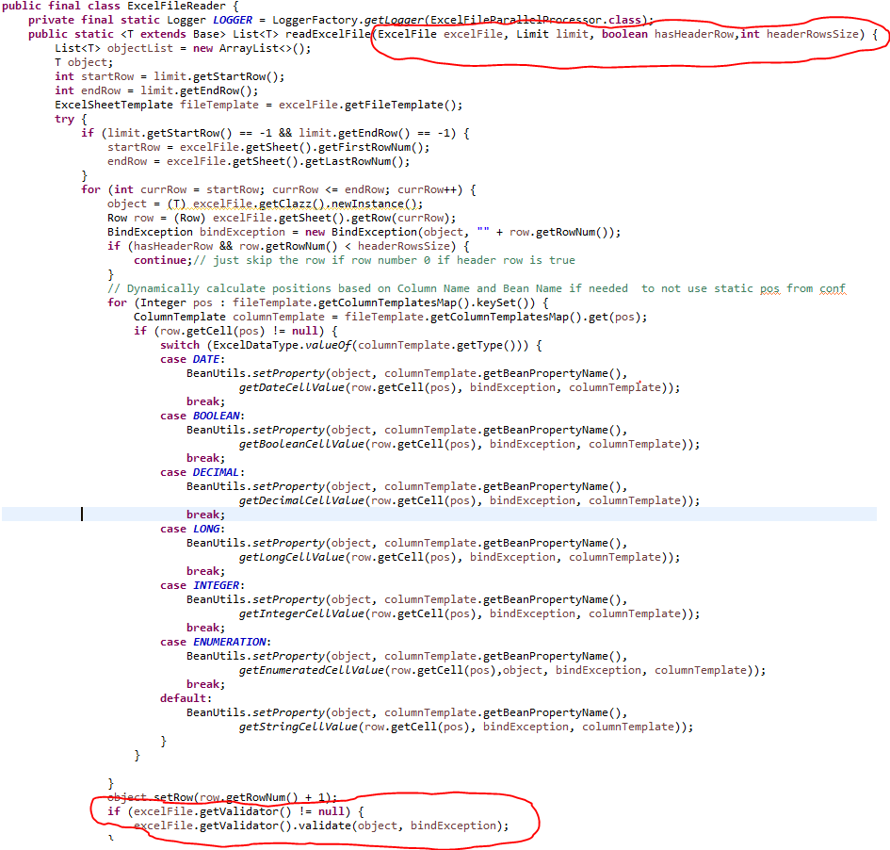

* ExcelFileReader will use ExcelFile object to read the object: ExcelFile.java

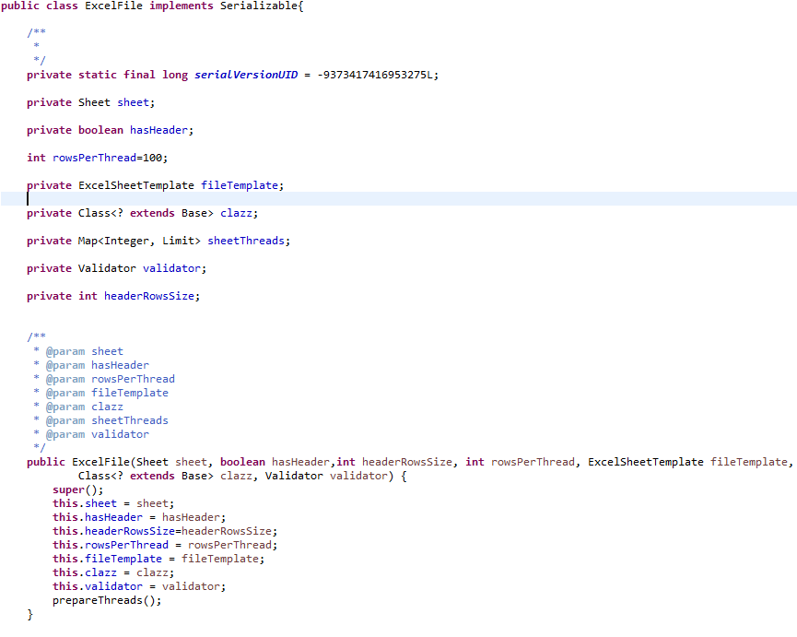

* ExcelFileReader will use the following validators and many more in future to validate the data after reading the excel file.
  + DonationValidator
  + ExpenseValidator
  + ProjectValidator
    - DonationValidator

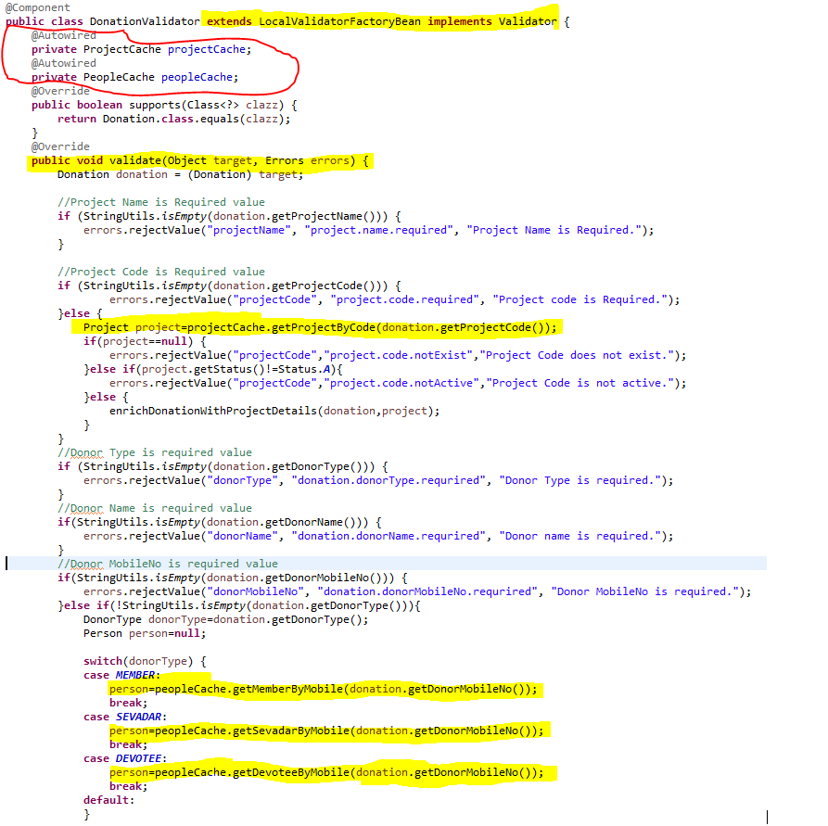

* + - ExpenseValidator

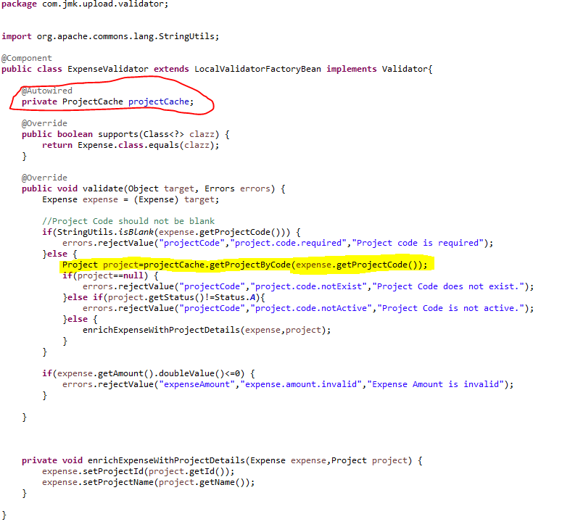

* + - ProjectValidator

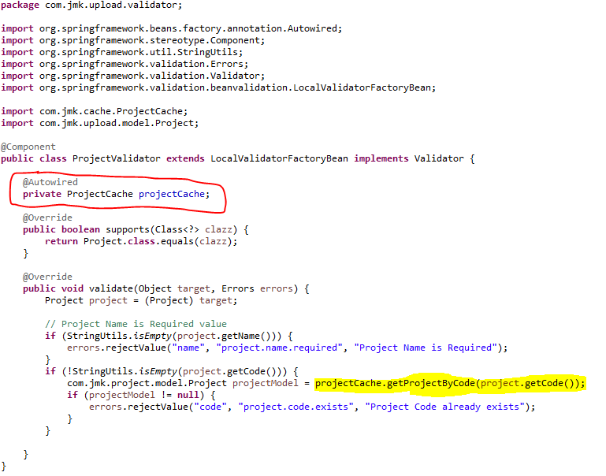

* To store the Validation result, used the ValidationResult class

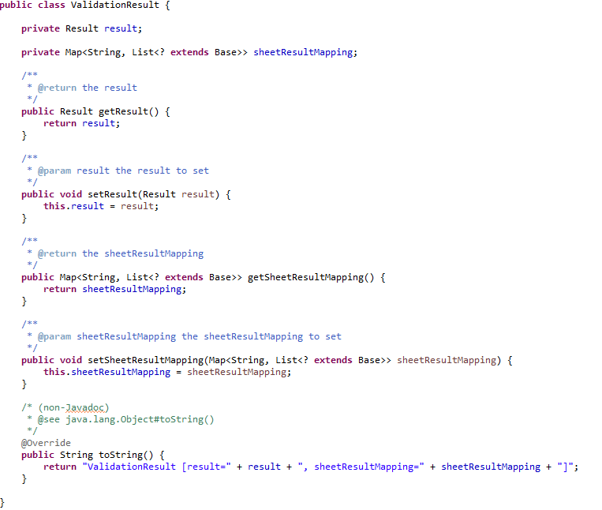

* **DataPersistenceService: Save the excel file data after successfully validating the excel file**
* DataPersistenceService

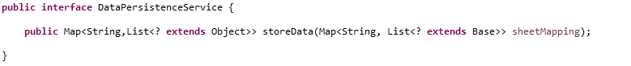

* DataPersistenceServiceImpl

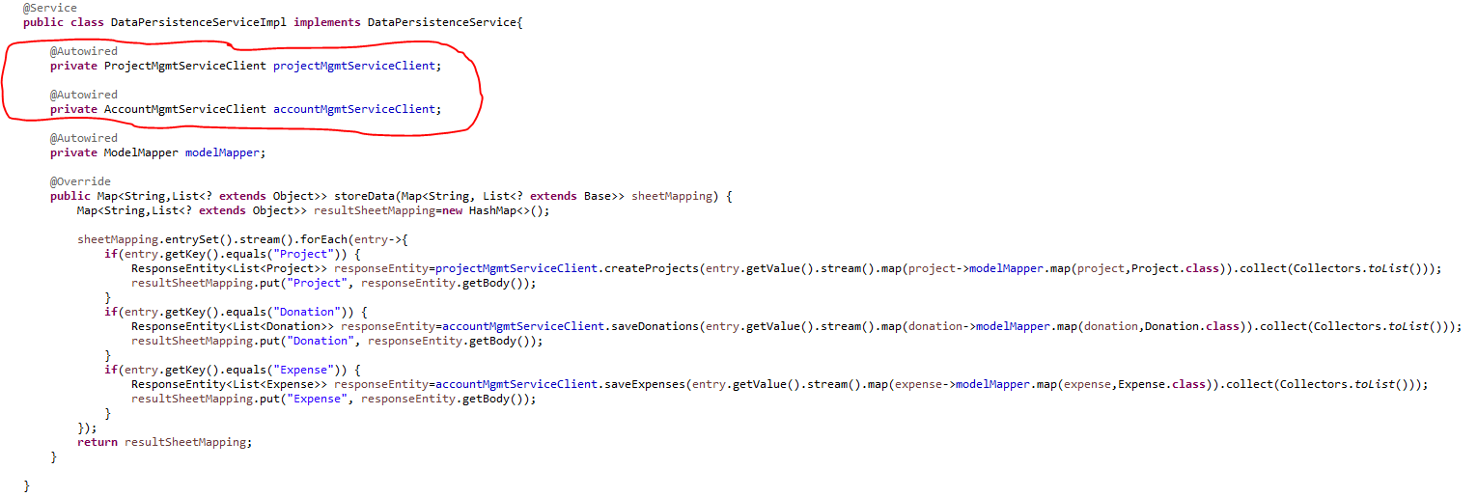

* **FeignClient to interact with other microservices to save the data.**
* ProjectMgmtServiceClient
* AccountMgmtServiceClient
  + ProjectMgmtServiceClient

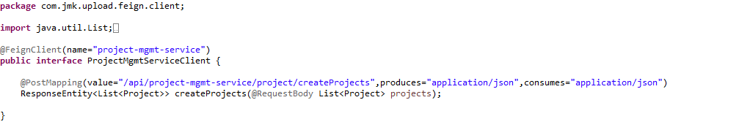

* + AccountMgmtServiceClient

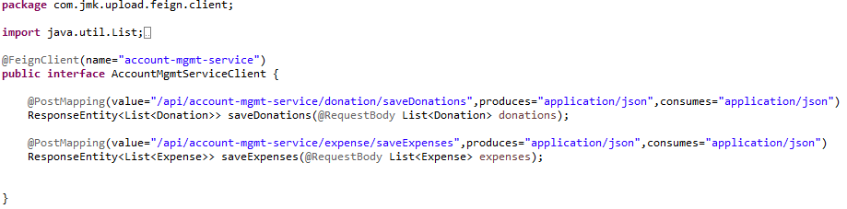

* + **To send the result to the client, use UploadFileResponse class**

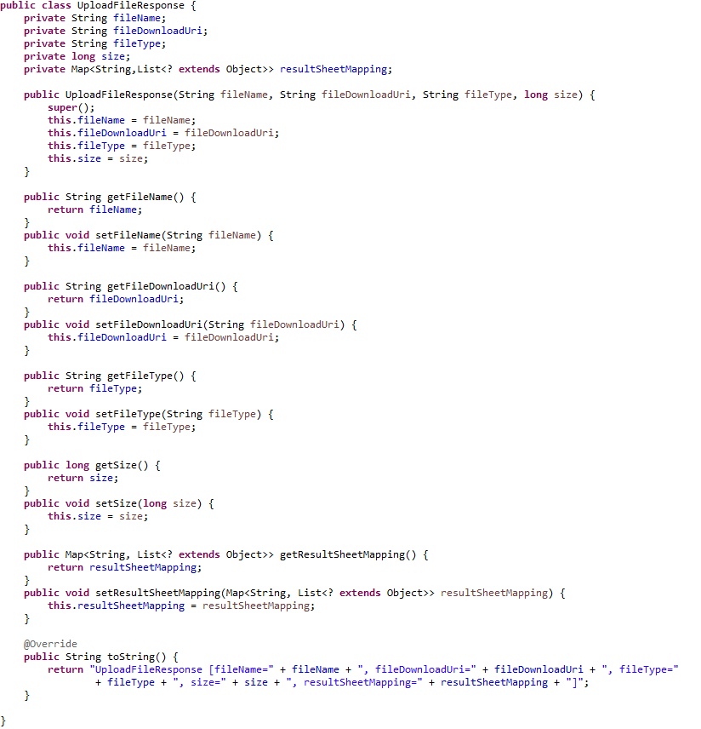

* Run the application as **Spring Boot App** in the following order
  + ConfigServerApplication
  + EurekaServerApplication
  + UserMgmtRestApplication
  + AuthServiceApplication
  + ZuulGatewayApplication
  + PeopleMgmtRestApplication
  + ProjectMgmtRestApplication
  + AccountMgmtRestApplication
  + DataUploadServiceApplication
* Open the browser of Eureka Server at localhost:8761, you should see the all the microservices running and enter the url: <http://localhost:8761/>

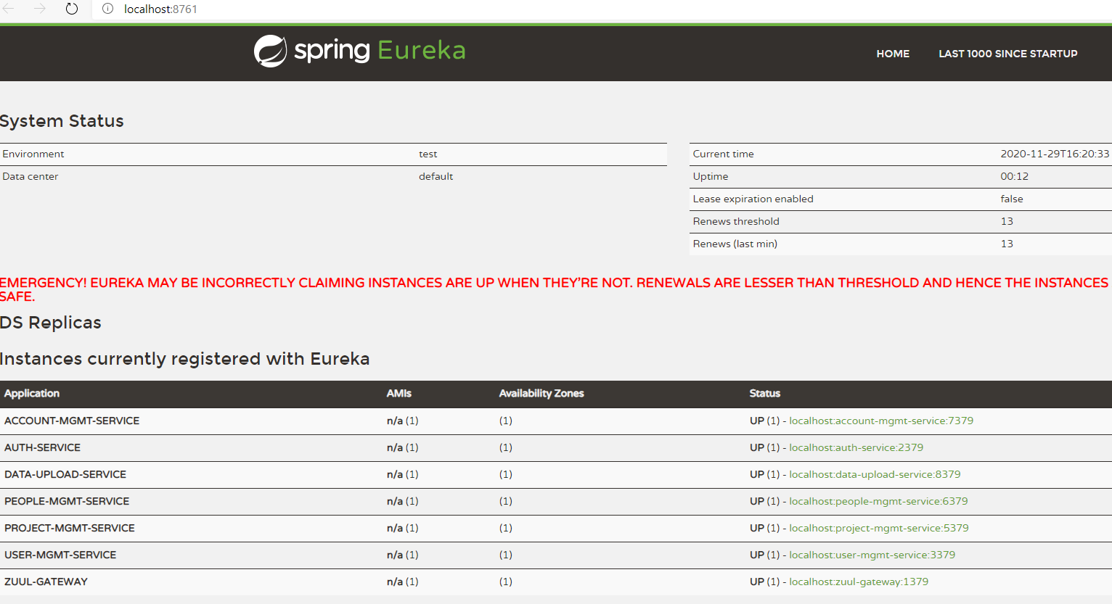

* Testing
  + Without authentication means directly hitting the data-upload-service running on 4379 and save the darshan details

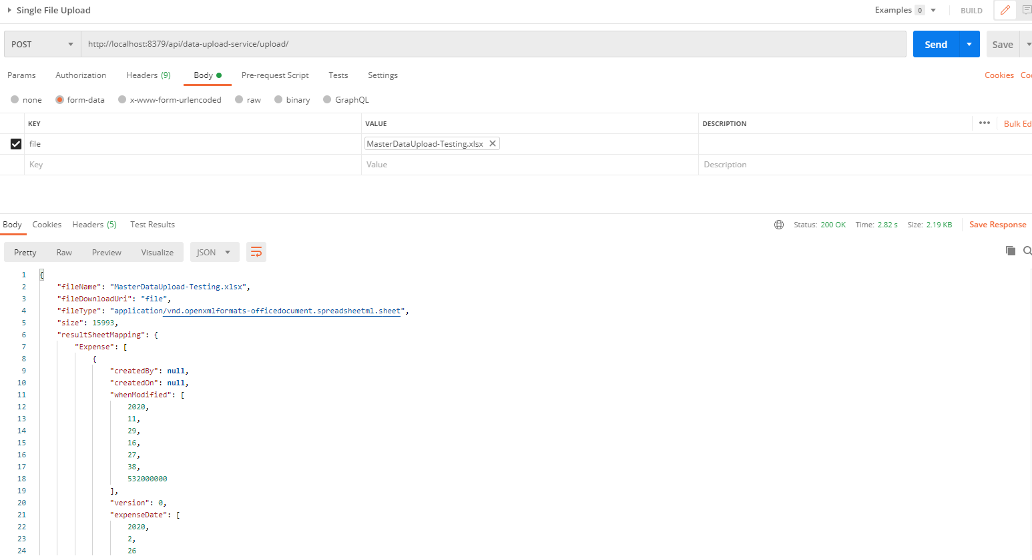

* + With authentication means every request to data-upload-service microservice will be hit via gateway running 1379
    - with authentication means every request to data-upload-service microservice will be hit via gateway running on 1379
      * uploading the data but without token means no authorization code (Bearer token) in the header will give the error.

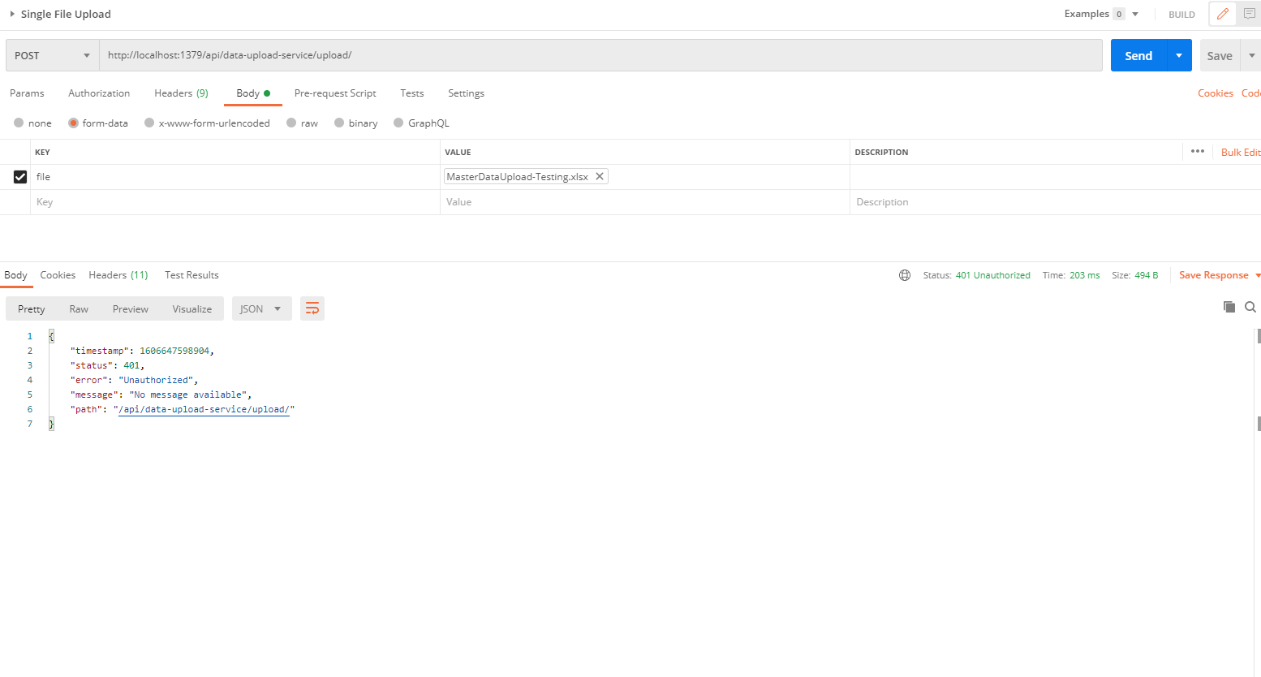

* Uploading file with token means authorization code (Bearer token) in the header will be provided using authentication service
  + 1. **To get authentication code in response header using authentication service**

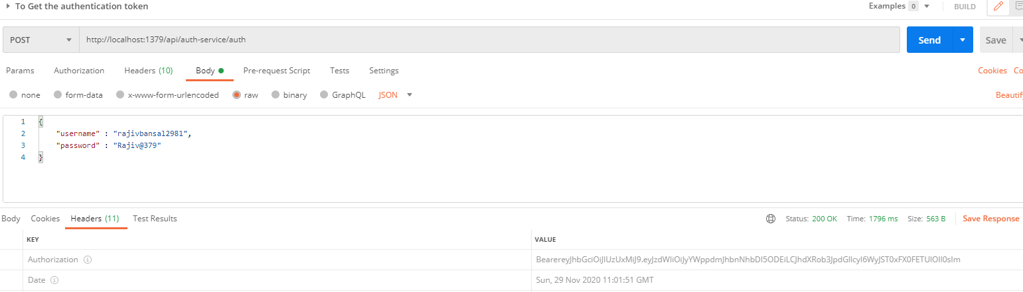

* + 1. **Now hit the** data-upload-service **to** upload the file by providing the token means authorization code (Bearer token) in the header received in above step
  + See the **Authorization** tab in the darshan request

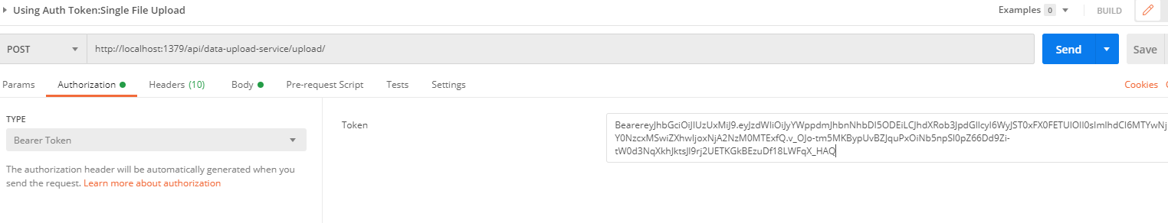

* + See the **Body** tab in the darshan request and response can be seen.

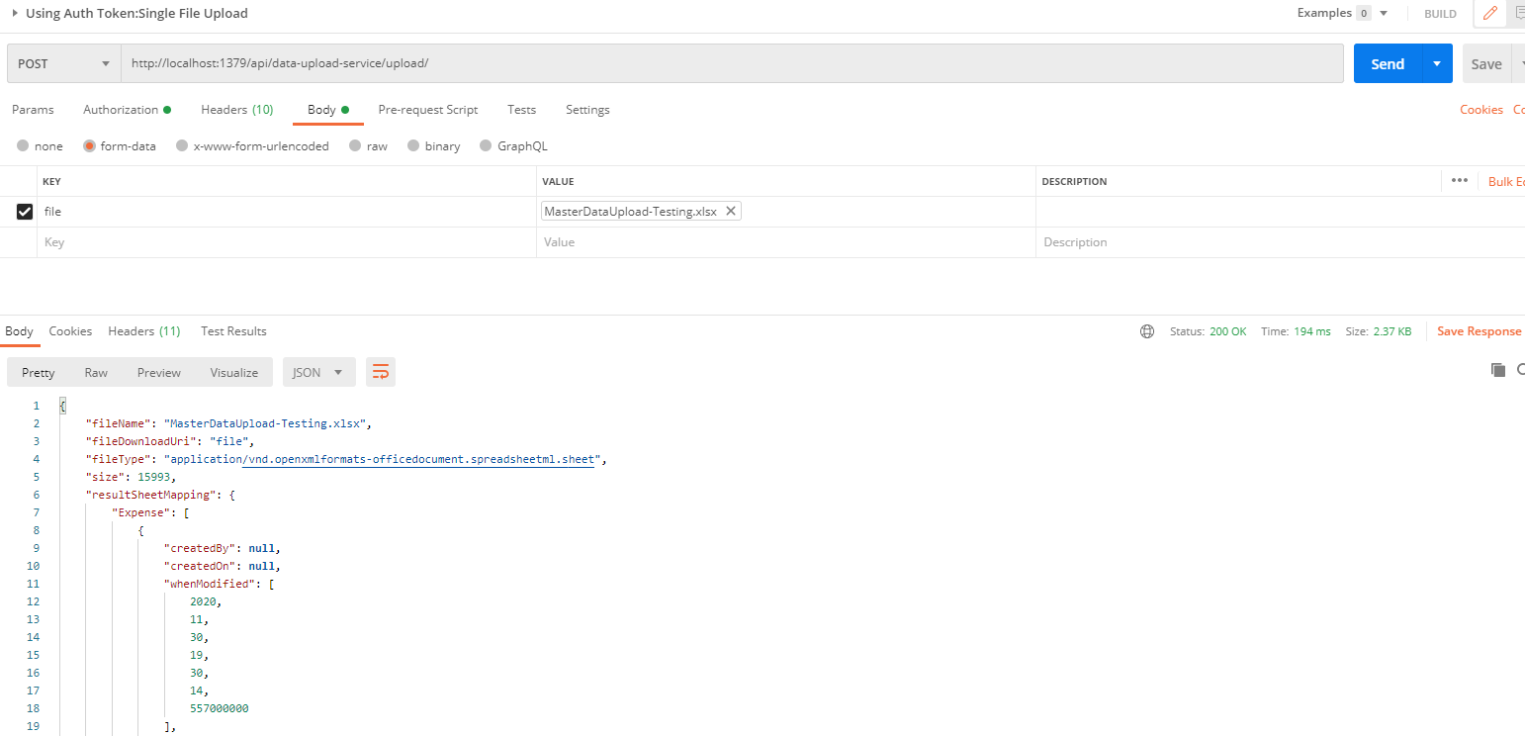

## **Cache Service**

This service will be used by other microservices to cache the reference entities. For example, this service will communicate with the people-mgmt-service, project-mgmt-service and user-mgmt-service using feign client to cache its entities.

Caching is a technique that involves the intermediate storage of data in very fast memory, usually. This means that this data can be made available much more quickly for subsequent requests since it does not have to be retrieved or recalculated from the primary and usually slower memory first.

Ehcache is an open source library implemented in Java for implementing caches in Java programs, especially local and distributed caches in main memory or on the hard disk. Thanks to the implementation of JSR-107, Ehcache is fully compatible with the javax.cache API.

* Create the Project using spring Starter Project.

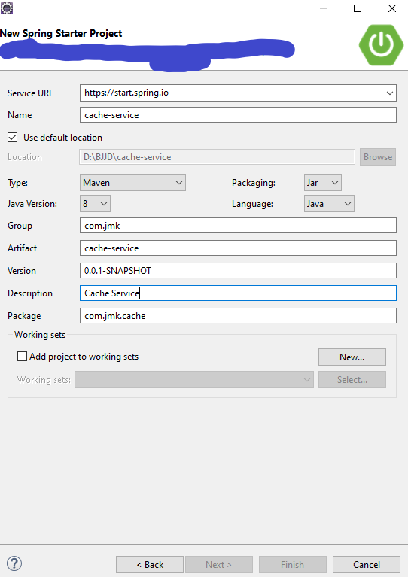

* Click on Next and Finish.
* Import the project.

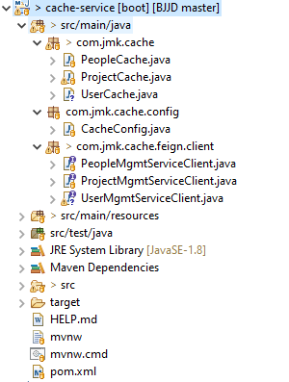

* Add the following dependencies in pom.xml with the following considerations:
  + Spring Boot Starter Parent: update the version: 2.2.4.RELEASE highlighted in yellow colour.
  + Spring Cloud version: upgraded to Hoston.SR4. It is highlighted in yellow colour.
  + Maven Jar Plugin Version: After the above updates, pom is giving compiler error in pom.xml so downgraded version of maven jar plugin to 3.1.1. It is highlighted in yellow colour.
  + Ehcache dependencies-api: ehcache, spring-boot-starter-cache and cache-api used to cache the entities.
  + Fiegn-Client: used to communicate with other microservices.

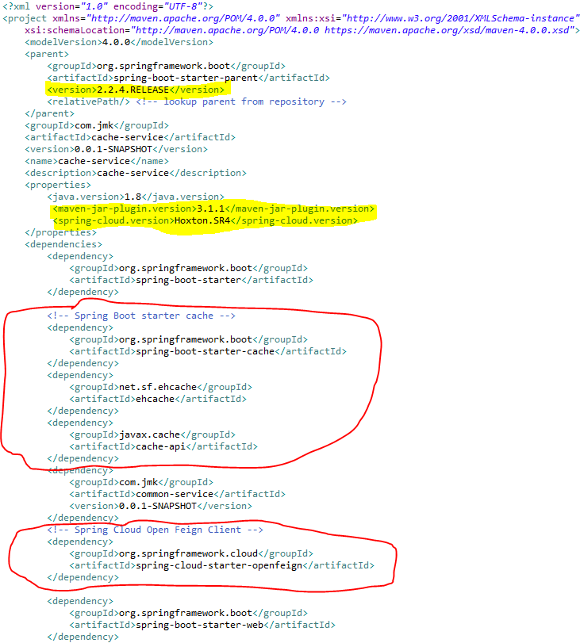

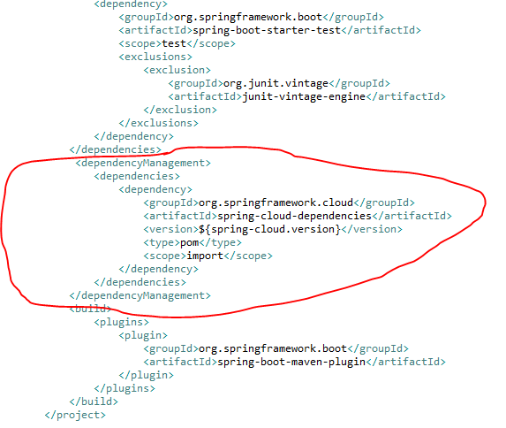

* Make application.properties empty as it is not required and will be referred by other microservices.
* Enable caching: To enable caching support in Spring Boot, we need a simple configuration class that must be annotated with @EnableCaching. Up to this point, we don’t need to do anything more as the following code shows:

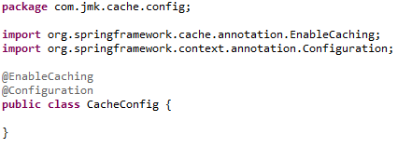

* **Cacheable operations**

Caching in Spring is basically applied to methods so that especially the calls of very costly operations can be reduced. We now want to add the result of this calculation to a cache depending on the radius passed by parameter, so that the calculation does not have to be repeated every time. To do this, we annotate the method with the @Cachable annotation:

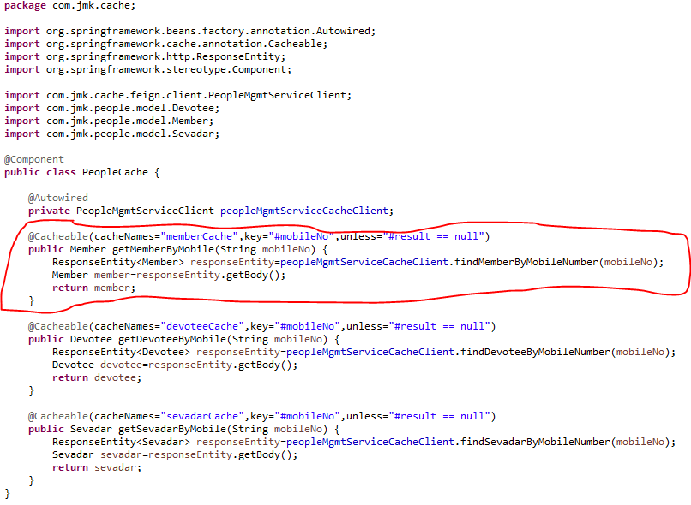

Each time this method is called with a radius greater than 5, the caching behavior is applied. This checks whether the method has already been called once for the specified parameter. If so, the result is returned from the cache and the method is not executed. If no, then the method is executed and the result is returned and stored in the cache.

The following parameters, among others, are available for annotation:

|  |  |
| --- | --- |
| **Annotation parameter** | **Description** |
| value / cacheNames | Name of the cache in which the results of the method execution are to be stored. |
| Key | The key for the cache entries as [Spring Expression Language (SpEL)](https://springframework.guru/introduction-spring-expression-language-spel/" \t "_blank). If the parameter is not specified, a key is created for all method parameters by default. |
| keyGenerator | Name of a bean that implements the KeyGenerator interface and thus allows the creation of a user-defined cache key. |
| Condition | Condition as Spring Expression Language (SpEL) that specifies when a result is to be cached. |
| Unless | Condition as Spring Expression Language (SpEL) that specifies when a result should not be cached. |

**Similar way, we have written cacheable operations for ProjectCache and UserCache**

**Project Cache**

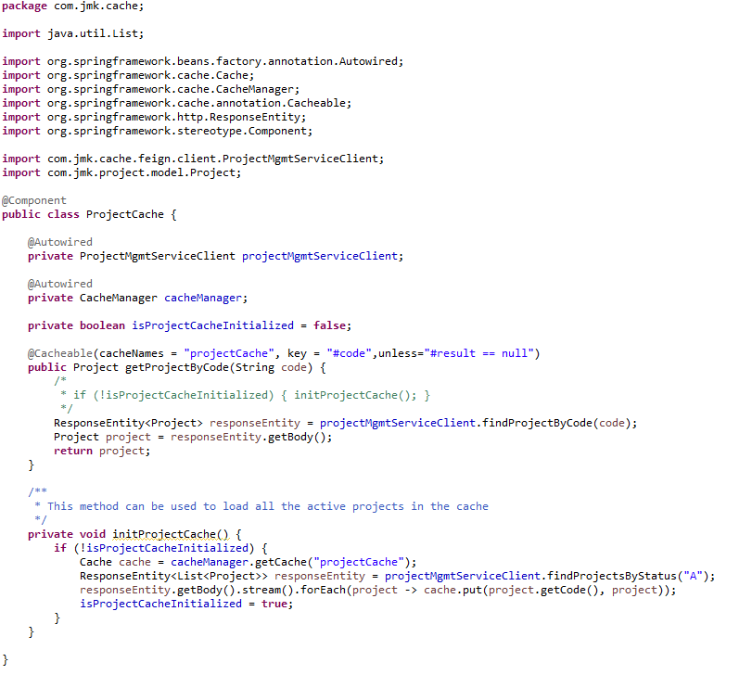

**UserCache**

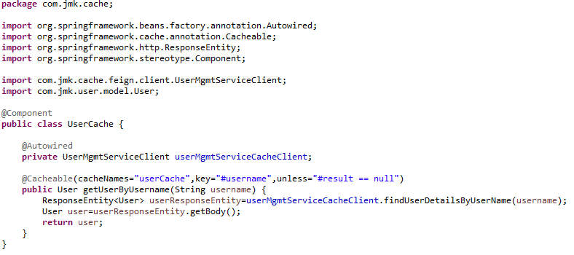

* **Ehcache Cache Configuration**

Now the configuration of the Ehcache cache has to be done. The configuration is XML-based. We create the XML file ehcache.xml in the resource folder of our application.

ehcache.xml is the configuration file used to configure the cache of entities.

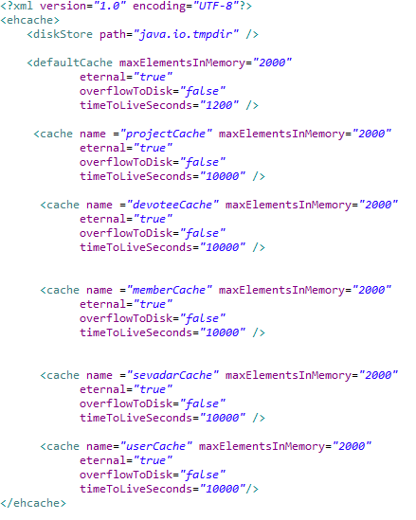

* Feign Client is being used to cache entities.
  + **FeignClient: ProjectMgmtServiceClient**

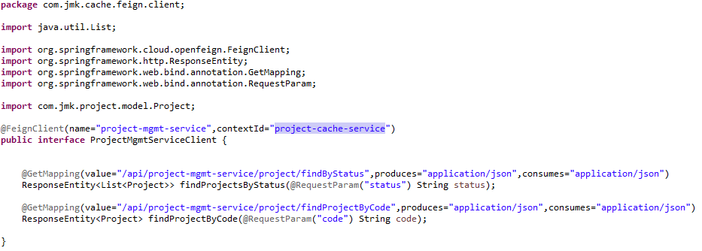

* + **FeignClient: PeopleMgmtServiceClient**

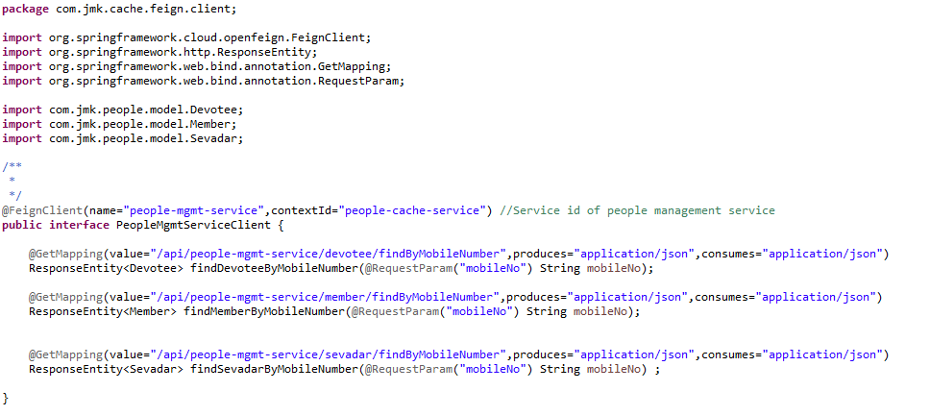

* + **FeignClient: UserMgmtServiceClient**

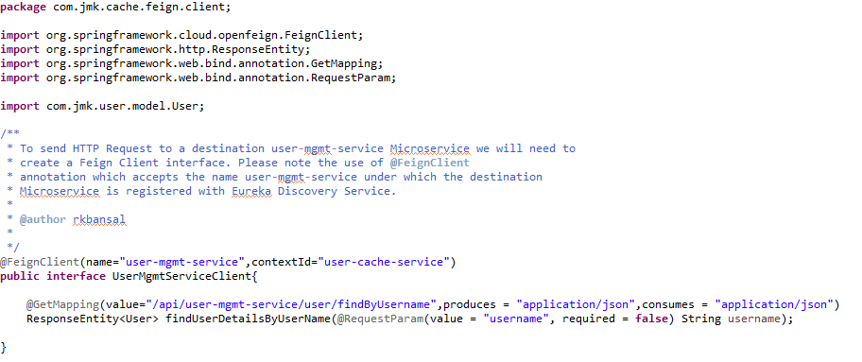

* **How to use the Cache in other projects.**

For example: darshan-mgmt-service

* + Import the dependency of cache-service

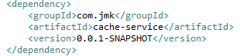

* + Enable the package scan of FeignClient which is used by cache class.

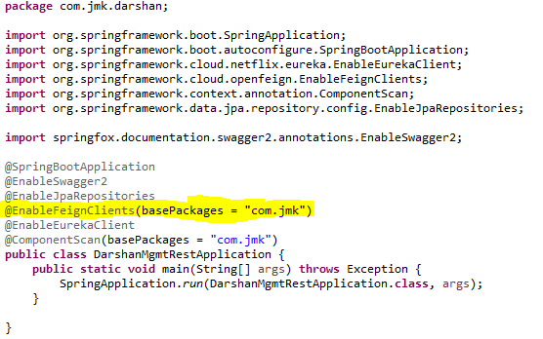

* + **Cache used In DarshanApiController**

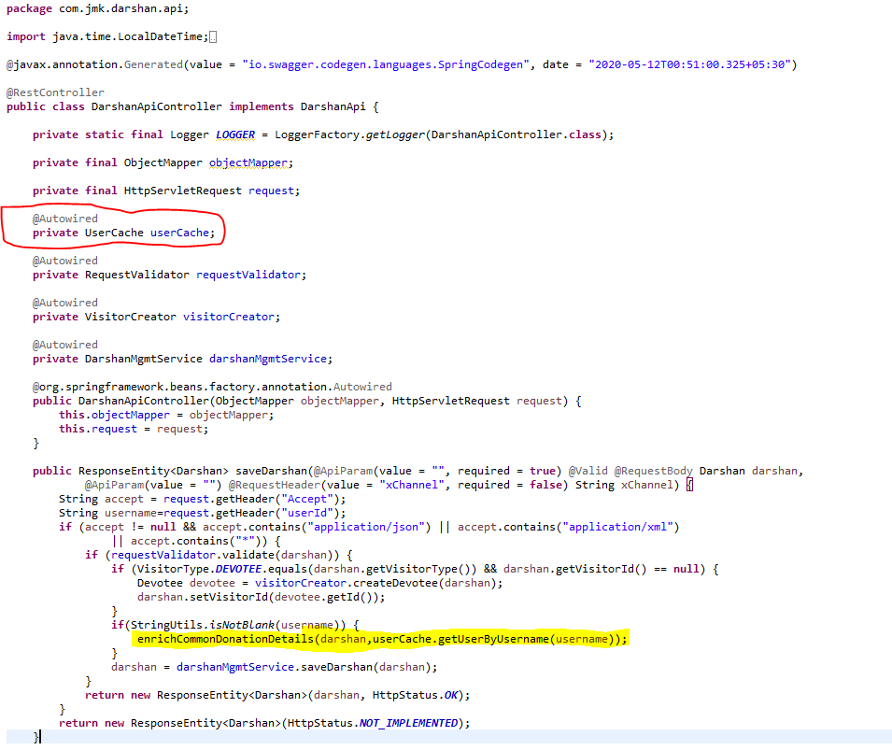

## **Message Sender Service (Kafka)**

**Why Kafka?**

Traditional messaging queues like ActiveMQ, RabbitMQ can handle high throughput usually used for long-running or background jobs and communicating between services.

Kafka is a stream-processing platform built by LinkedIn and currently developed under the umbrella of the Apache Software Foundation. Kafka aims to provide low-latency ingestion of large amounts of event data.

**We can use Kafka when we have to move a large amount of data and process it in real-time**. An example would be when we want to process user behavior on our website to generate product suggestions or monitor events produced by our micro-services.

Kafka is built from ground up with horizontal scaling in mind. We can scale by adding more brokers to the existing Kafka cluster.

**Kafka Vocabulary**

Let’s look at the key terminologies of Kafka:

* **Producer**: A producer is a client that sends messages to the Kafka server to the specified topic.
* **Consumer**: Consumers are the recipients who receive messages from the Kafka server.
* **Broker**: Brokers can create a Kafka cluster by sharing information using Zookeeper. A broker receives messages from producers and consumers fetch messages from the broker by topic, partition, and offset.
* **Cluster**: Kafka is a distributed system. A Kafka cluster contains multiple brokers sharing the workload.
* **Topic**: A topic is a category name to which messages are published and from which consumers can receive messages.
* **Partition**: Messages published to a topic are spread across a Kafka cluster into several partitions. Each partition can be associated with a broker to allow consumers to read from a topic in parallel.
* **Offset**: Offset is a pointer to the last message that Kafka has already sent to a consumer.
* To work with Kafka, need to install and setup Kafka.

1. To download and install Kafka, please refer the official guide [https://kafka.apache.org/quickstart](https://kafka.apache.org/quickstart" \t "_blank) . Click on the following selected link.

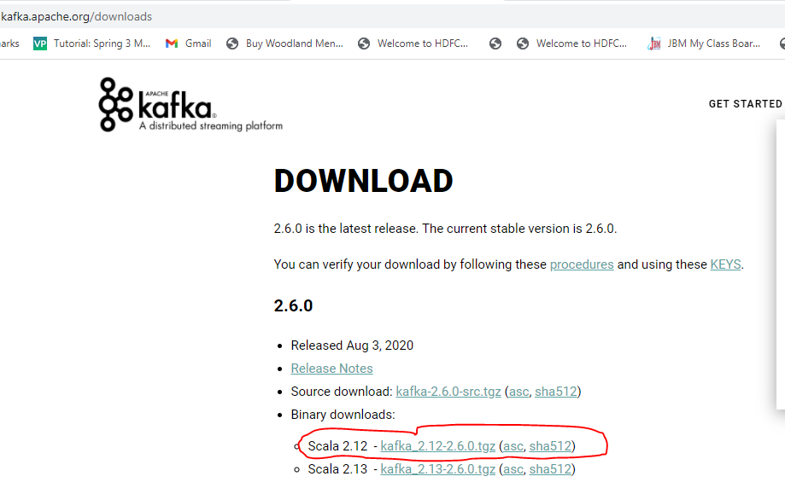

1. Unzip the kafka\_2.12-2.6.0.tgz file.
2. **Create data folder and subfolders: zookeeper and kafka in the main directory: kafka\_2.12-2.6.0**

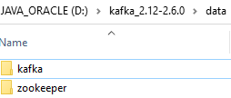

1. **Change the default configuration value**
   1. Update dataDir in zookeeper.properties file located in “D:\kafka\_2.12-2.6.0\config\zookeeper.properties” configuration file.

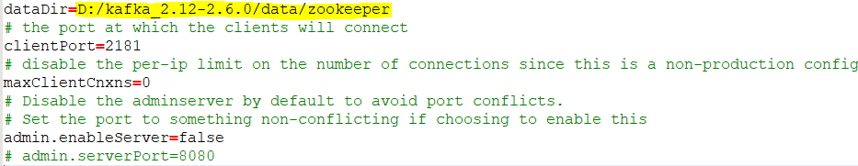

* 1. Update logs.dir in server.properties file located in “D:\kafka\_2.12-2.6.0\config\server.properties” configuration file.

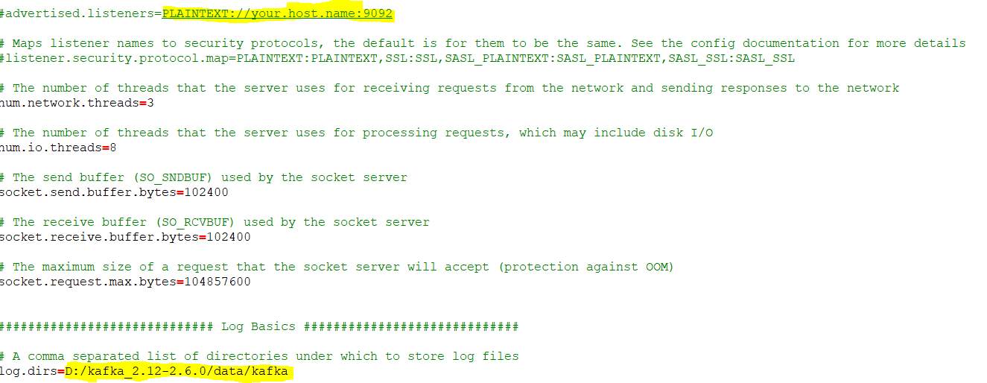

1. **Start Zookeeper**

Now time to start zookeeper from command prompt. Change your directory to **D:\kafka\_2.12-2.6.0\bin\windows** and execute **zookeeper-server-start.bat** command with config/zookeeper.properties configuration file.

D:\kafka\_2.12-2.6.0\bin\windows>zookeeper-server-start.bat ../../config/zookeeper.properties

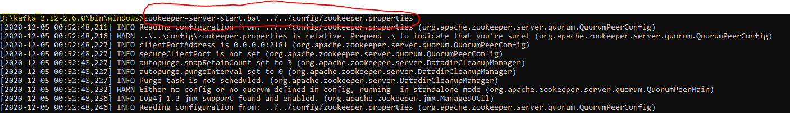

1. **Start Kafka**

Finally time to start Apache Kafka from command prompt. Change your directory to **D:\kafka\_2.12-2.6.0\bin\windows** and run **kafka-server-start.bat**command with kafka config/server.properties configuration file.

D:\kafka\_2.12-2.6.0\bin\windows>kafka-server-start.bat ../../config/server.properties

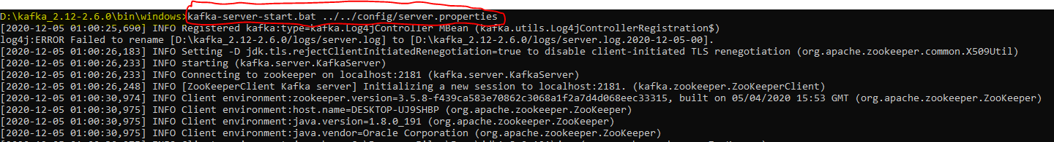

1. Now, by default, the Kafka server starts on localhost:9092.

* Create the Project using spring Starter Project.

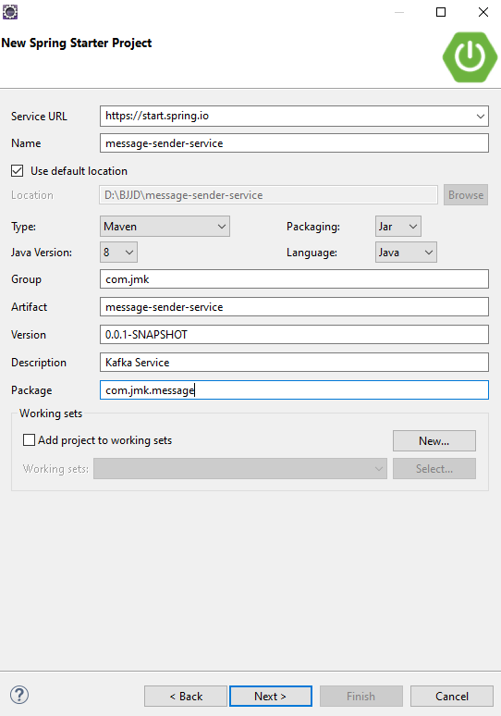

* Click on Next and Finish.

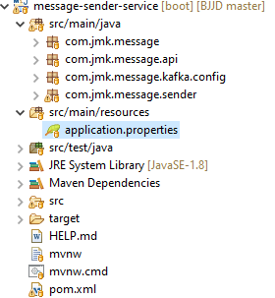

* Import the Project
* Add the following dependencies in pom.xml with the following considerations:
  + Spring Boot Starter Parent: update the version: 2.2.4.RELEASE highlighted in yellow colour.
  + Spring Cloud version: upgraded to Hoston.SR4. It is highlighted in yellow colour.
  + Maven Jar Plugin Version: After the above updates, pom is giving compiler error in pom.xml so downgraded version of maven jar plugin to 3.1.1. It is highlighted in yellow colour.
  + Spring Kafka:  used to publish and subscribe the messages based on the fault-tolerant messaging system.  It is fast, scalable and distributed by design.

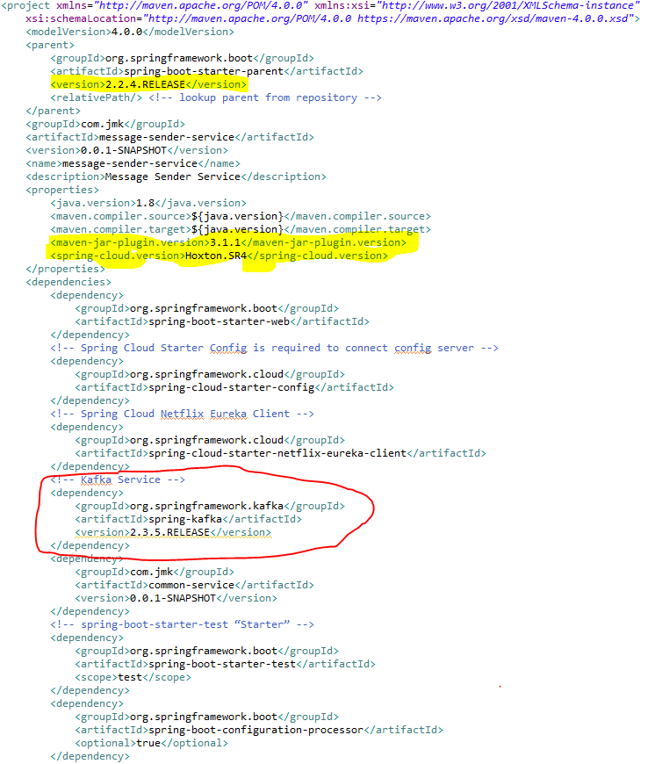

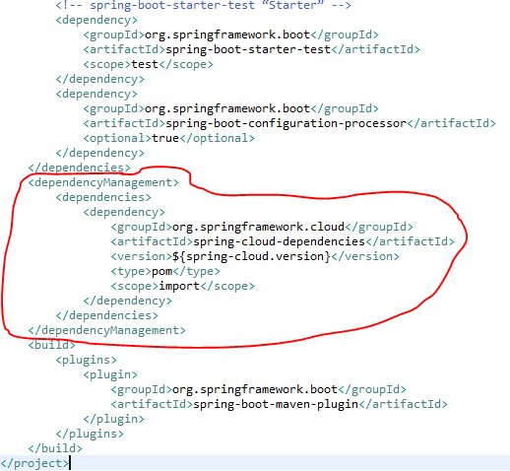

* Update the MessageSenderServiceApplication.java with the following details:
  + Enable Eureka Client so that it can be register with Eureka Server
  + Enable JpaRepositories
  + Enable FeignClient to interact with user-mgmt-service, people-mgmt-service.
  + Enable EnableSwagger2 so that we can view the document api
  + Enable Kafka and Async communication

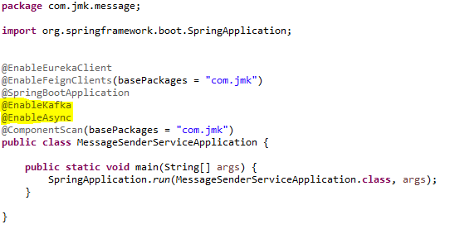

* application.properties : Make application.properties empty as it is not required here and will be referred in other microservices. Will define the properties of spring.kafka in other microservices.
* Spring Boot does most of the configuration automatically, so we can focus on building the listeners and producing the messages. It also provides the option to override the default configuration through application.properties. The Kafka configuration is controlled by the configuration properties with the prefix spring.kafka.\*:

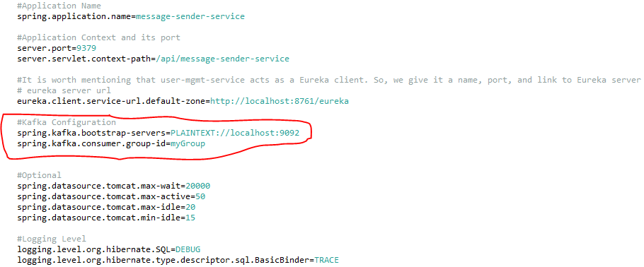

* To split up responsibilities, we have created two projects:
  + Message-sender-service: It is related to pushing the message on the topic using Spring Producer Configuration. i.e. current section going on.
  + Message-consumer-service: It is related to listening the message received on the topic using kafka consumer configuration. It will be the next topic.
* Kafka Message Producer Configuration

Let’s have a look at the producer configuration first.

## **Messaging Consumer Service (Kafka and Twilio)**

This service will send the message to the user using the following medium:

* WhatsApp
* Email
* SMS
* Create the Project using spring Starter Project.

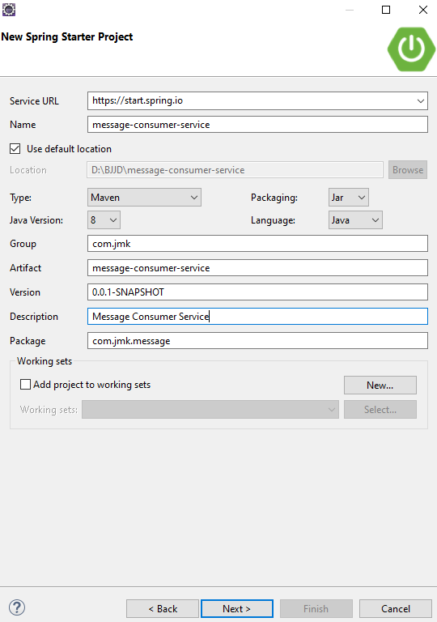

* Click on Next and select the Spring Web Module.



* Click on Finish and import the project.

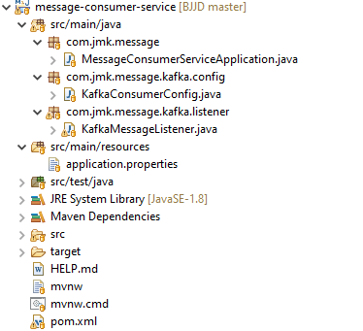

* Import the Project
* Add the following dependencies in pom.xml with the following considerations:
  + Spring Boot Starter Parent: update the version: 2.2.4.RELEASE highlighted in yellow colour.
  + Spring Cloud version: upgraded to Hoston.SR4. It is highlighted in yellow colour.
  + Maven Jar Plugin Version: After the above updates, pom is giving compiler error in pom.xml so downgraded version of maven jar plugin to 3.1.1. It is highlighted in yellow colour.
  + Spring Kafka:  used to publish and subscribe the messages based on the fault-tolerant messaging system.  It is fast, scalable and distributed by design.

## **Get LoggedInUser Details in other microservices**

Please follow the steps to get the user details in other microservices:

* Add pre type Filter in Zuul-gateway application: CurrentUserAuthenticationFilter

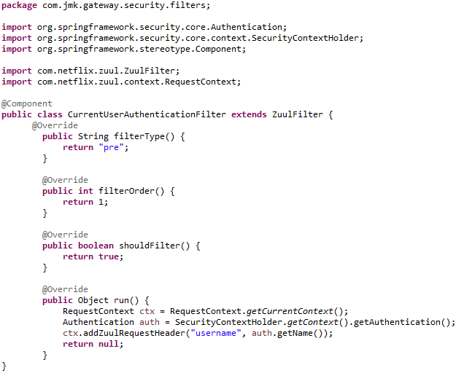

* Now we can retrieve the username by fetching the request header details in any other microservice. And based on the username, we can retrieve the details of user anytime by communicating user-mgmt-service using feign client implemented by cache-service. Please refer cache-service to see the implementation of UserCache and its communication with user-mgmt-service using feign client.

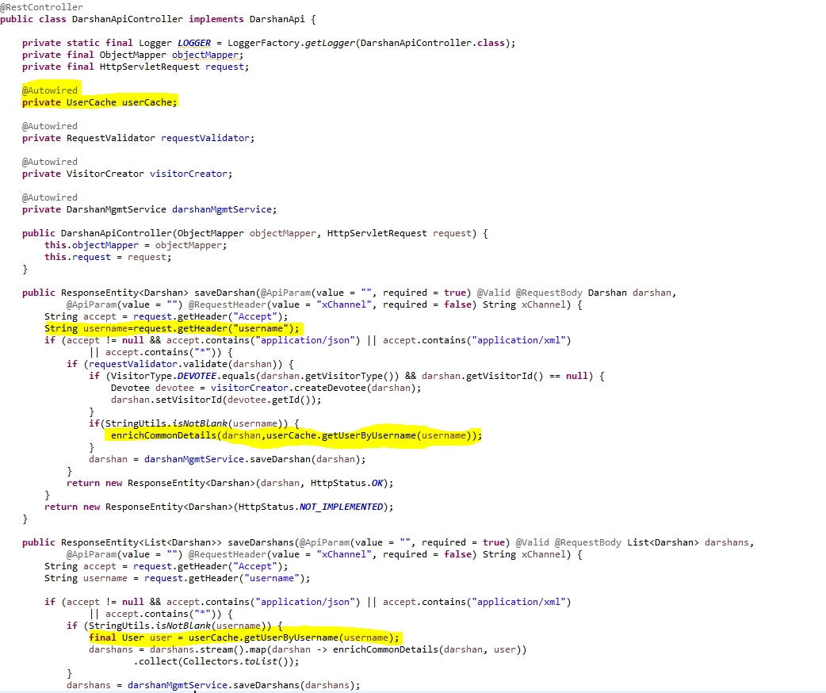

## **Caching using Hazelcast (Embedded Distributed Cache)**

We have used Hazelcast for the embedded distributed cache in our project.

Hazelcast IMDG is a perfect fit for your (micro)services running on Kubernetes since it can be used in the embedded mode and therefore scale in and out together with your service replicas. This blog post presents a step-by-step description of how to embed Hazelcast into a Spring Boot application and deploy it in the Kubernetes cluster.

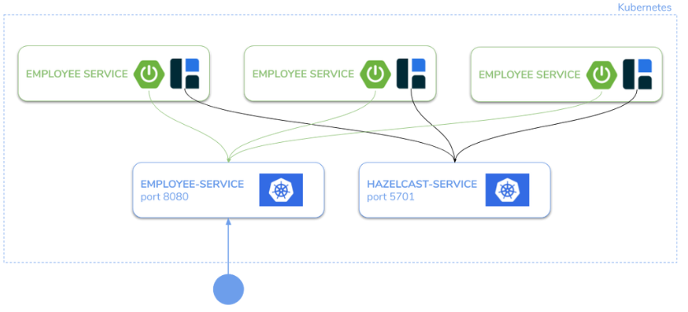

#### **Step 1: Configure Hazelcast to work on Kubernetes**

Make sure you have the following Maven dependencies:

<dependency>

<groupId>com.hazelcast</groupId>

<artifactId>hazelcast-all</artifactId>

<version>4.1</version>

</dependency>

#### **Step 2: Configure the Hazelcast Cache Configuration**

* Configure the Hazelcast Cache in the two ways:
  + If application is running in the Dev environment

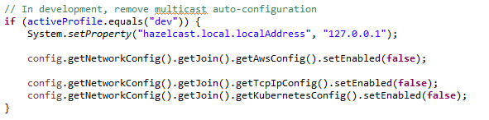

* + If application is running in the Kubernetes Environment (Prod)

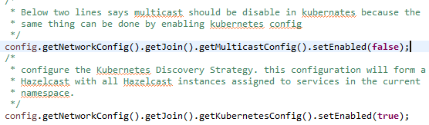

* HazelcastCacheConfiguration.java file to configure the Hazelcast Cache.

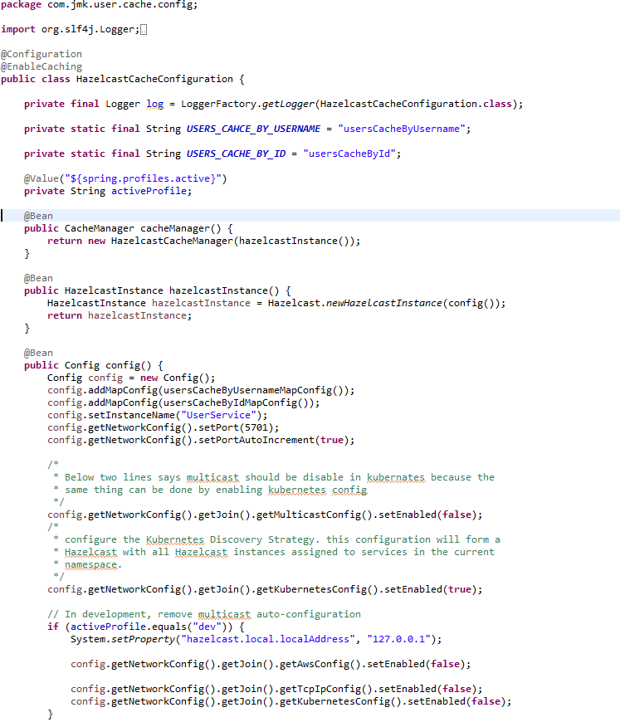

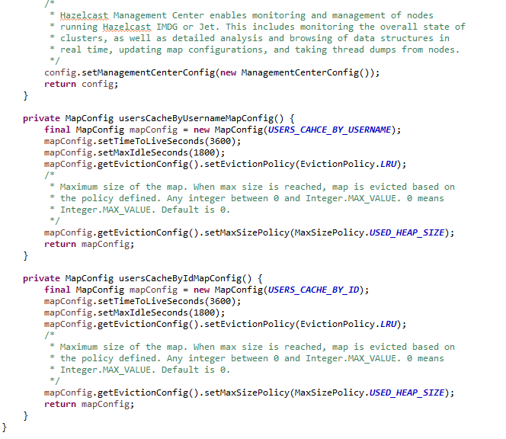

#### **Step 3: Use of Hazelcast Cache:**

1. User Service Implementation should be exposed as following:
   1. Implementations of Hazelcast Cache.

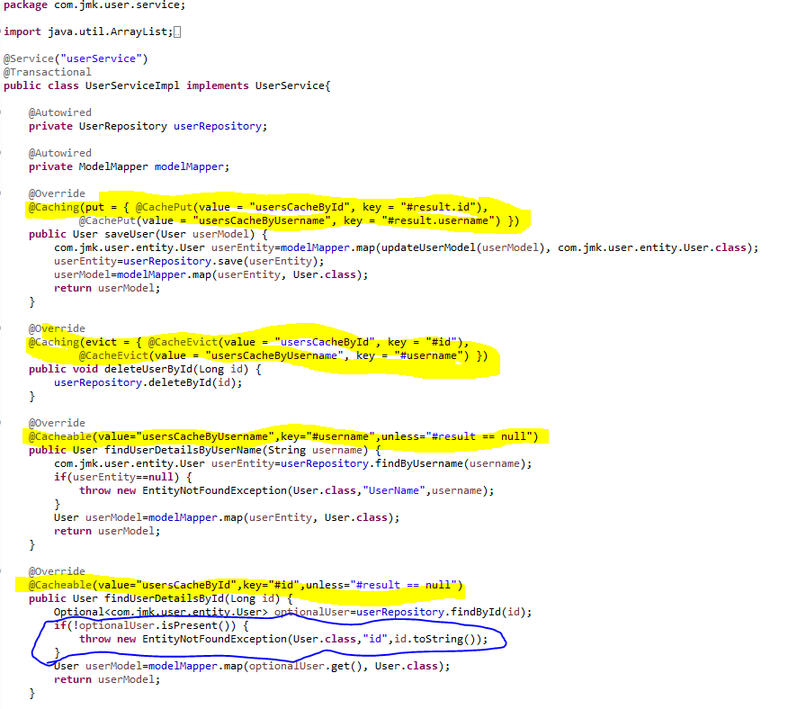

#### **Step 4: Grant access to Kubernetes API**

Hazelcast uses Kubernetes API for auto-discovery. That is why you need to grant certain roles to your service account. You can do it by creating the following “rbac.yaml” file.

apiVersion: rbac.authorization.k8s.io/v1

kind: ClusterRoleBinding

metadata:

name: default-cluster

roleRef:

apiGroup: rbac.authorization.k8s.io

kind: ClusterRole

name: view

subjects:

- kind: ServiceAccount

name: default

namespace: default

Then, apply it into your Kubernetes cluster.

kubectl apply -f rbac.yaml

#### **Step 5: Deploy the application**

Create “deployment.yaml” with Deployment and Service which will use the image you pushed to Docker Hub.

apiVersion: apps/v1

kind: Deployment

metadata:

name: hazelcast-embedded

spec:

replicas: 2

selector:

matchLabels:

app: hazelcast-embedded

template:

metadata:

labels:

app: hazelcast-embedded

spec:

containers:

- name: hazelcast-embedded

image: leszko/hazelcast-embedded-sample

imagePullPolicy: Always

ports:

- containerPort: 5701

- containerPort: 8080

---

apiVersion: v1

kind: Service

metadata:

name: hazelcast-embedded

spec:

type: LoadBalancer

selector:

app: hazelcast-embedded

ports:

- name: hazelcast

port: 5701

- name: app

port: 8080

Then, to deploy an application, run the following command:

kubectl apply -f deployment.yaml

#### **Step 6: Verify that the application works correctly**

You can check that the Deployment and Service were created.

$ kubectl get all

NAME READY STATUS RESTARTS AGE

pod/hazelcast-embedded-57f84c545b-64tnk 1/1 Running 0 2m

pod/hazelcast-embedded-57f84c545b-jjhcs 1/1 Running 0 45s

NAME TYPE CLUSTER-IP EXTERNAL-IP PORT(S) AGE

service/hazelcast-embedded LoadBalancer 10.19.251.145 104.154.43.142 5701:32302/TCP,8080:31613/TCP 2m

NAME DESIRED CURRENT UP-TO-DATE AVAILABLE AGE

deployment.extensions/hazelcast-embedded 2 2 2 2 2m

NAME DESIRED CURRENT READY AGE

replicaset.extensions/hazelcast-embedded-57f84c545b 2 2 2 2m

NAME DESIRED CURRENT UP-TO-DATE AVAILABLE AGE

deployment.apps/hazelcast-embedded 2 2 2 2 2m

NAME DESIRED CURRENT READY AGE

replicaset.apps/hazelcast-embedded-57f84c545b 2 2 2 2m

In the logs for PODs, you should see that the Hazelcast members formed a cluster.

$ kubectl logs pod/hazelcast-embedded-57f84c545b-jjhcs

...

Members {size:2, ver:4} [

Member [10.16.2.6]:5701 - 33076b61-e99d-46f2-b5c1-35e0e75f2311

Member [10.16.2.8]:5701 - 9ba9bb61-6e34-460a-9208-c5a644490107 this

]

...

Then, you can access the application, by its EXTERNAL-IP.